ACM-ICPC Team Note



Decentralization

중앙대학교

팀원 : 박인서, 한재민, 이호민

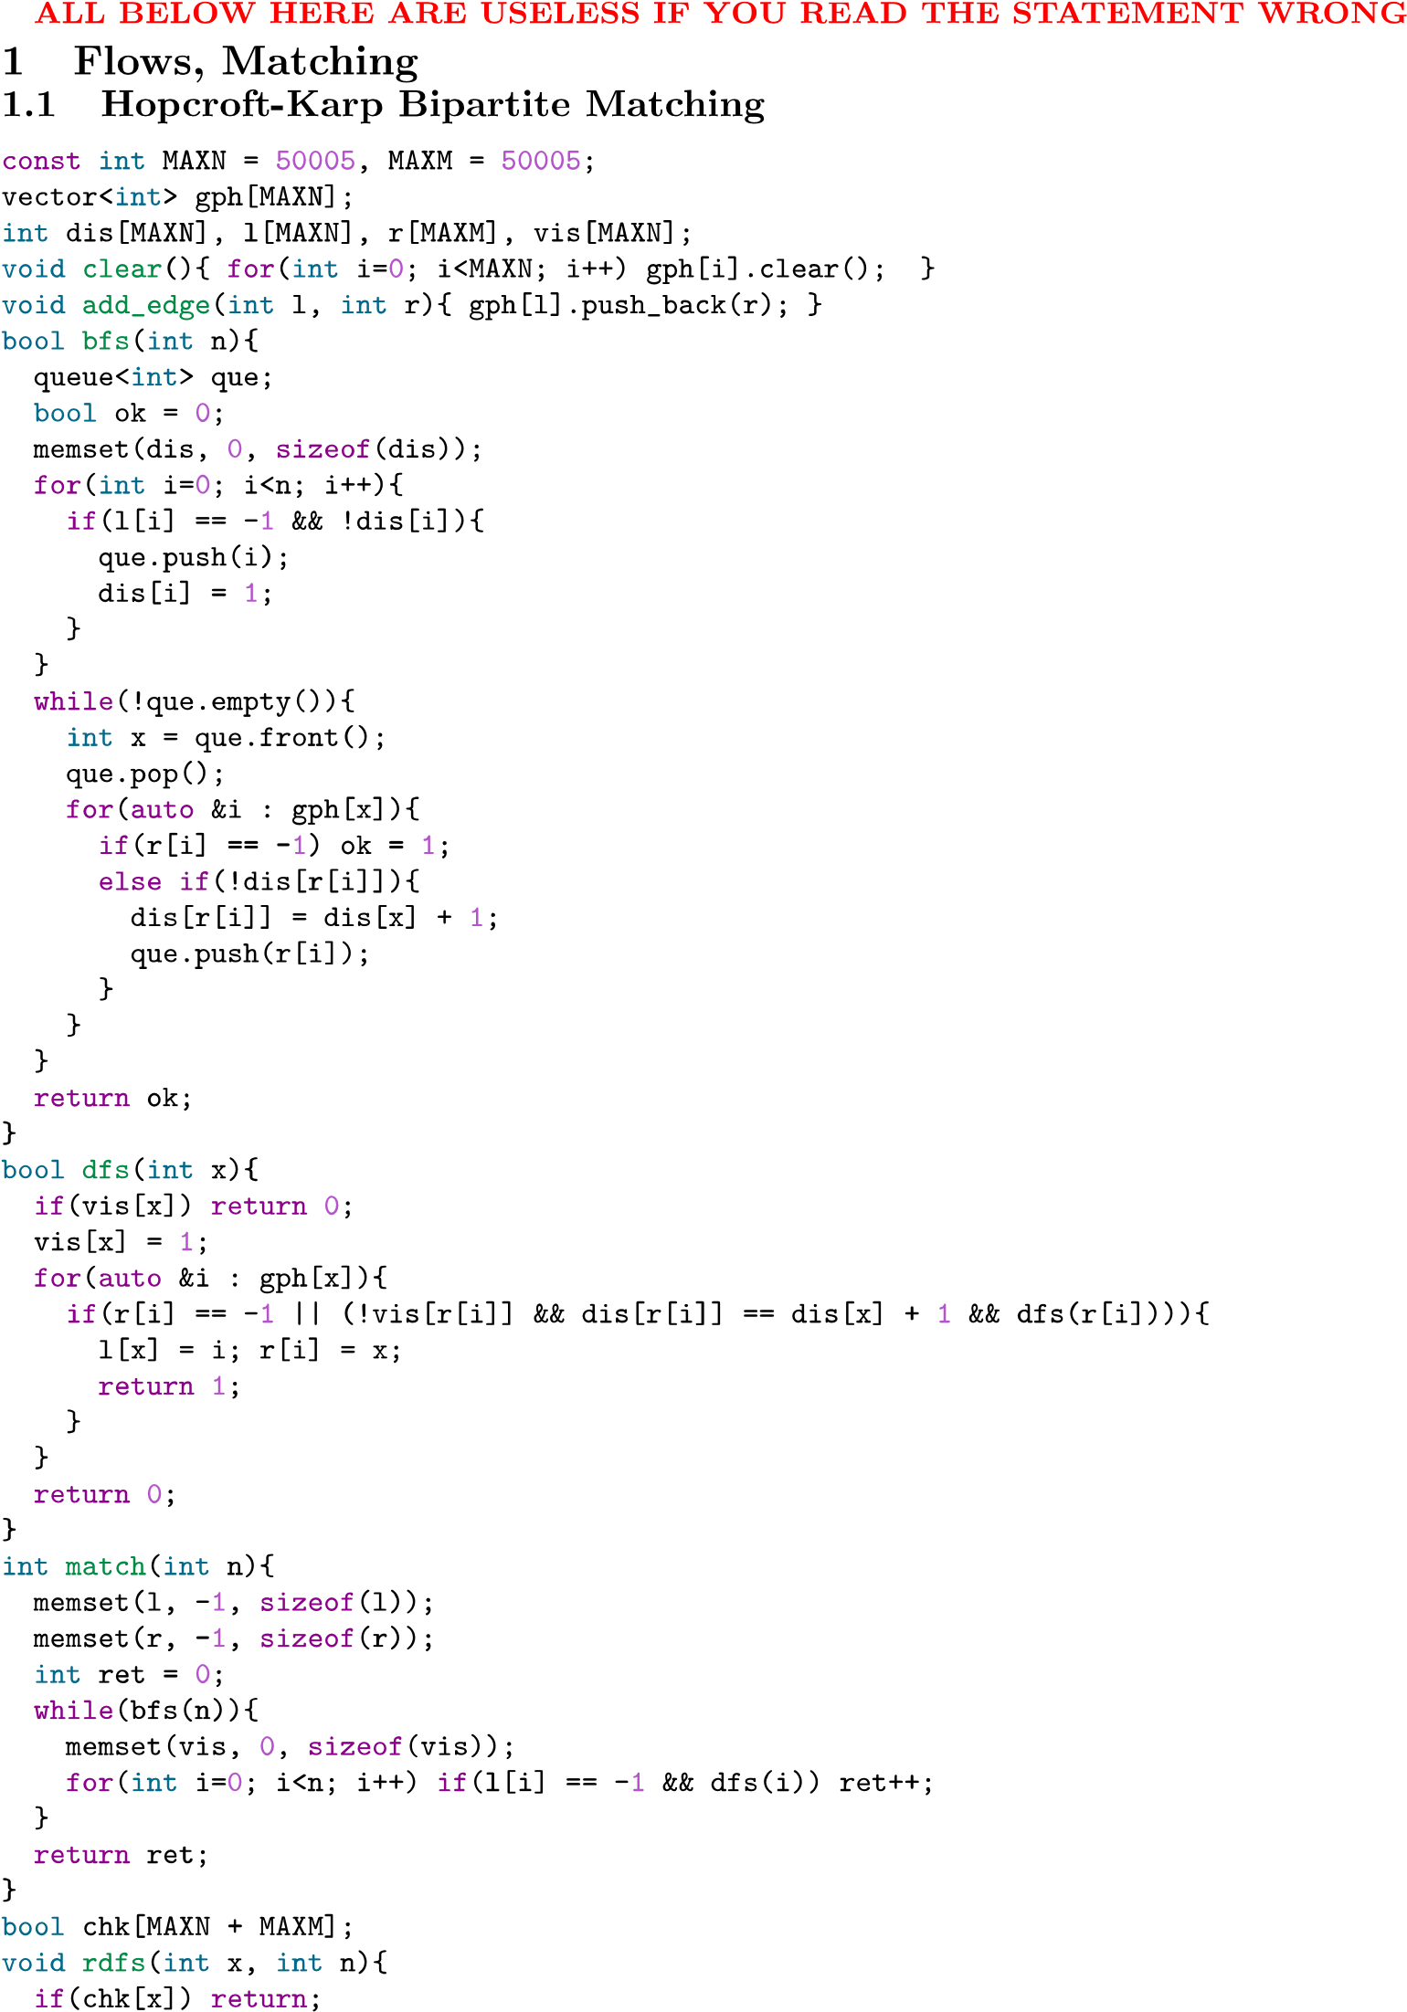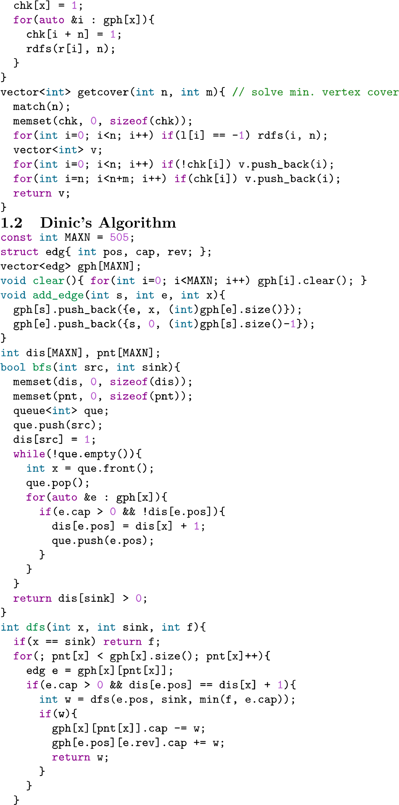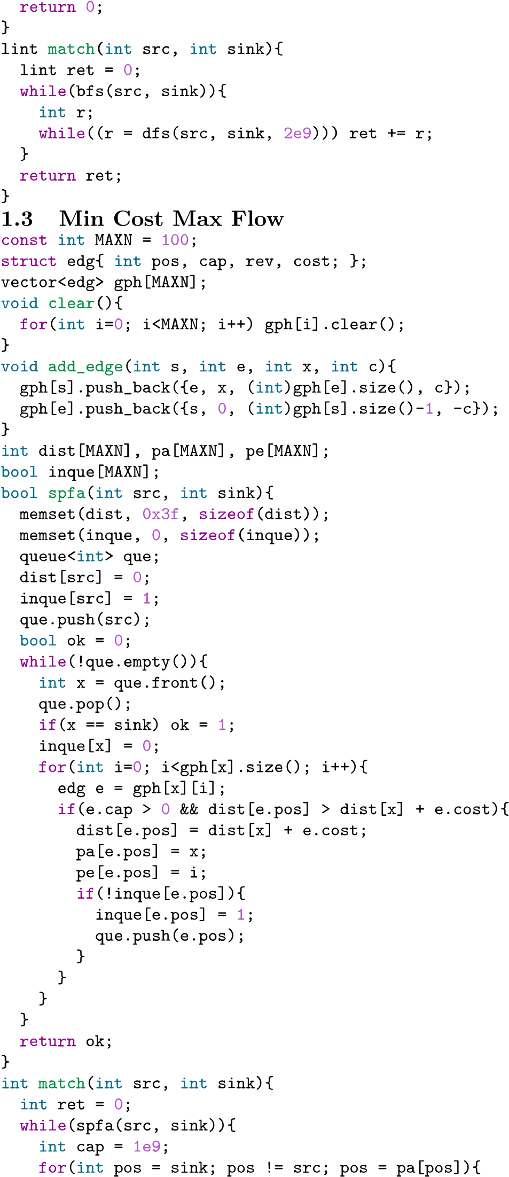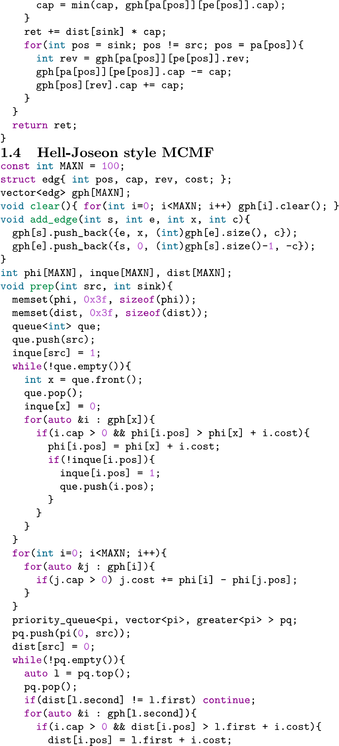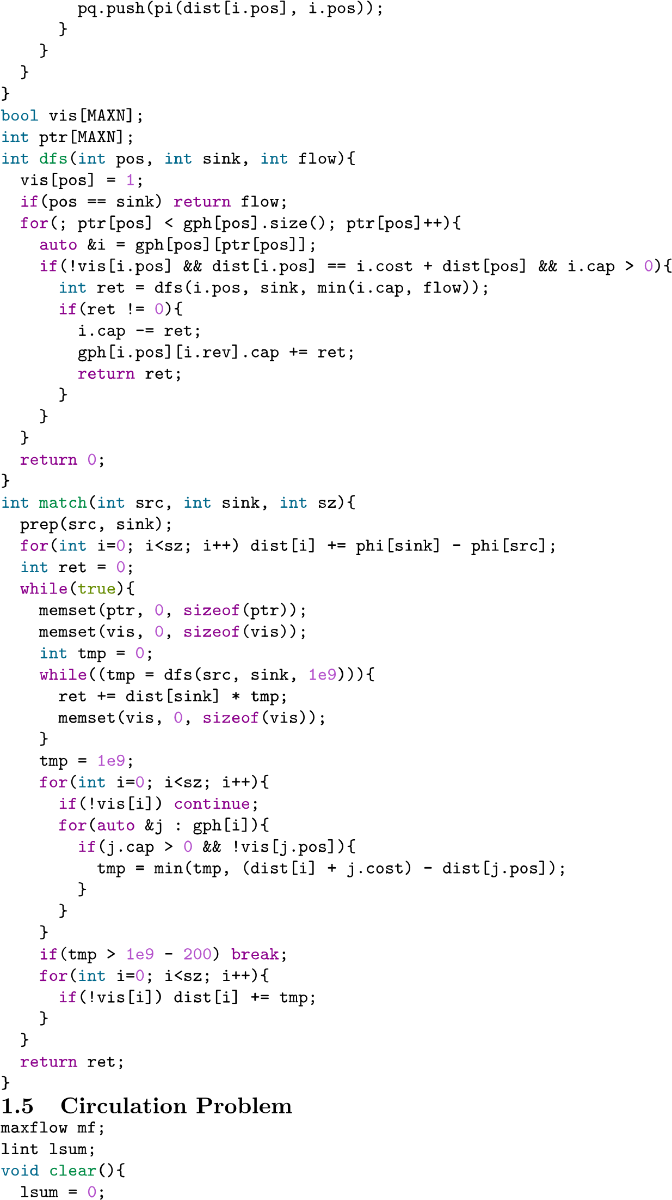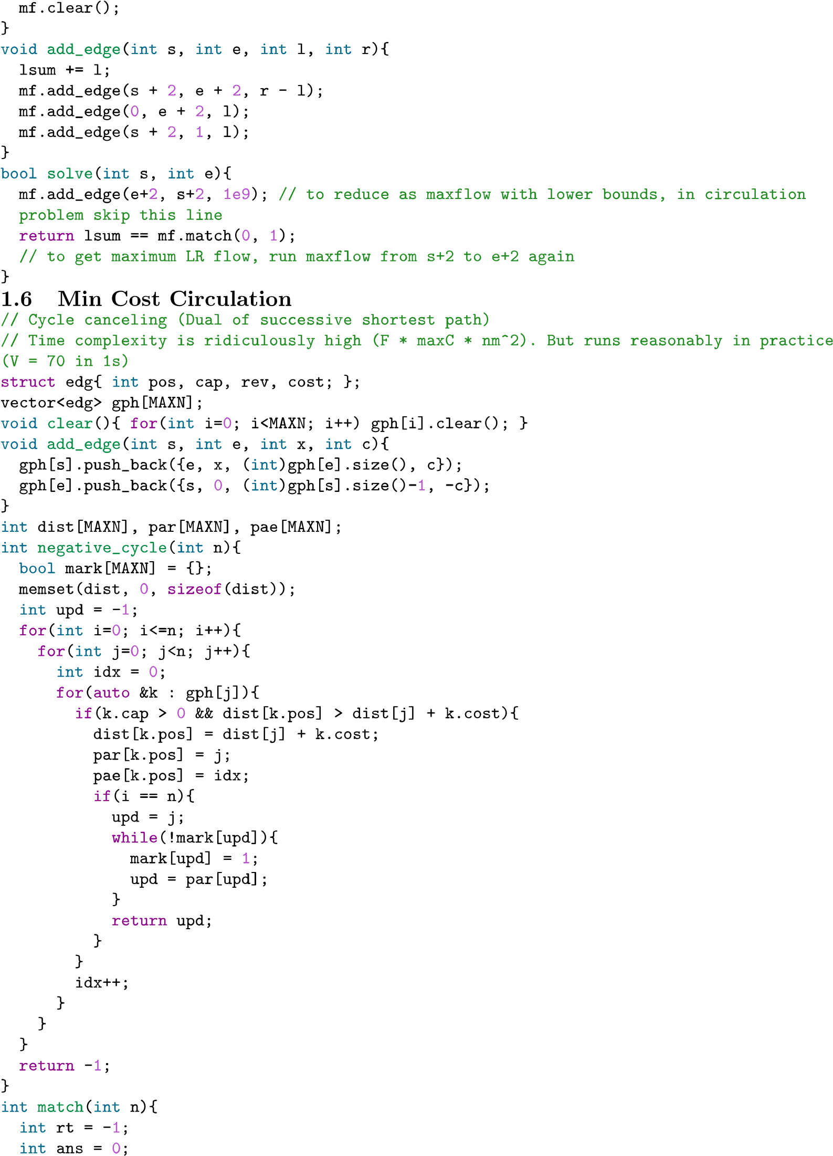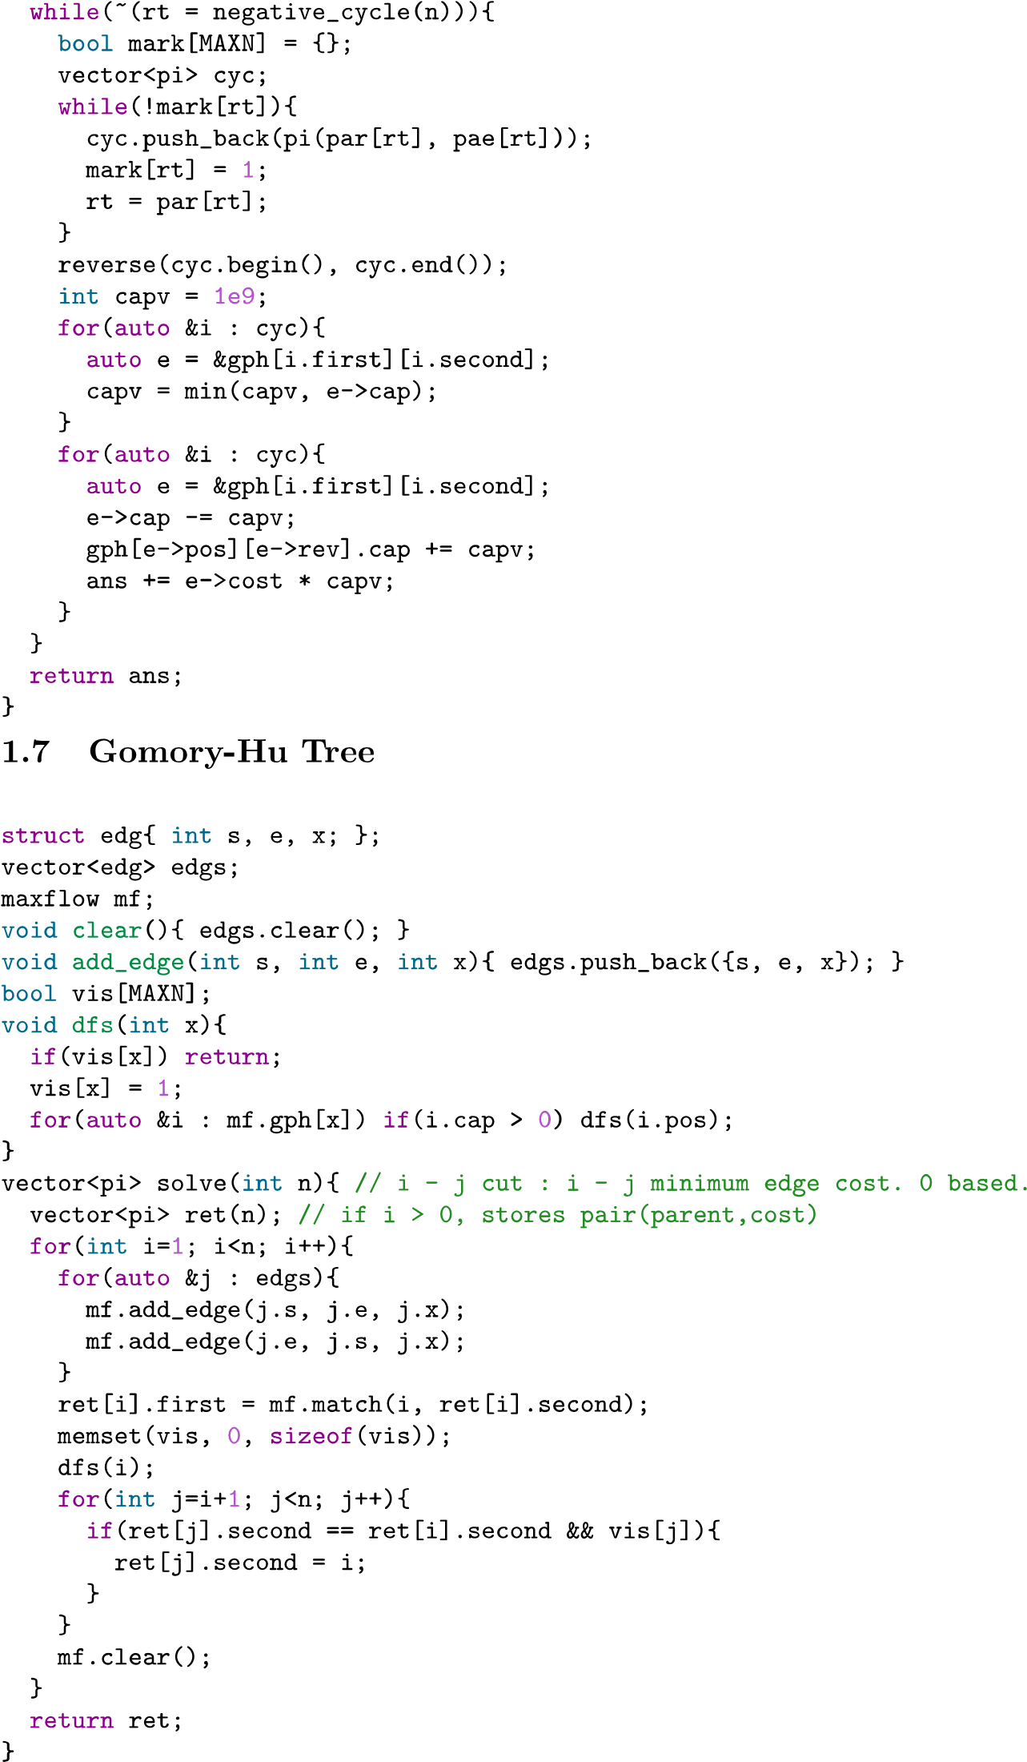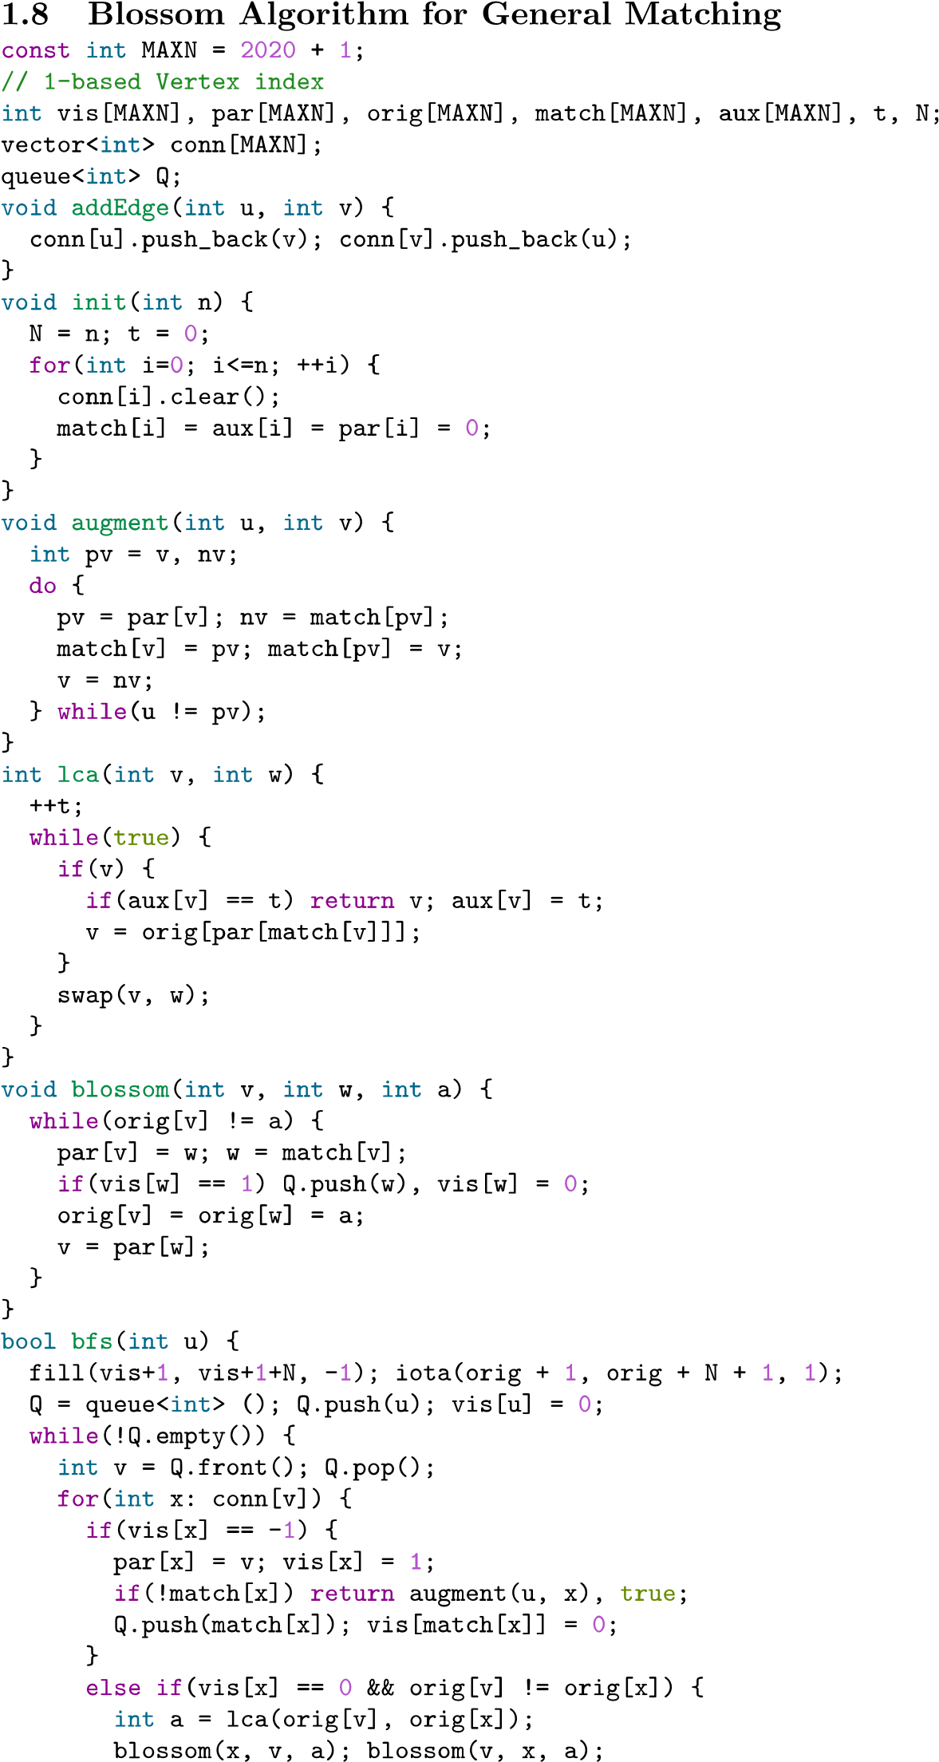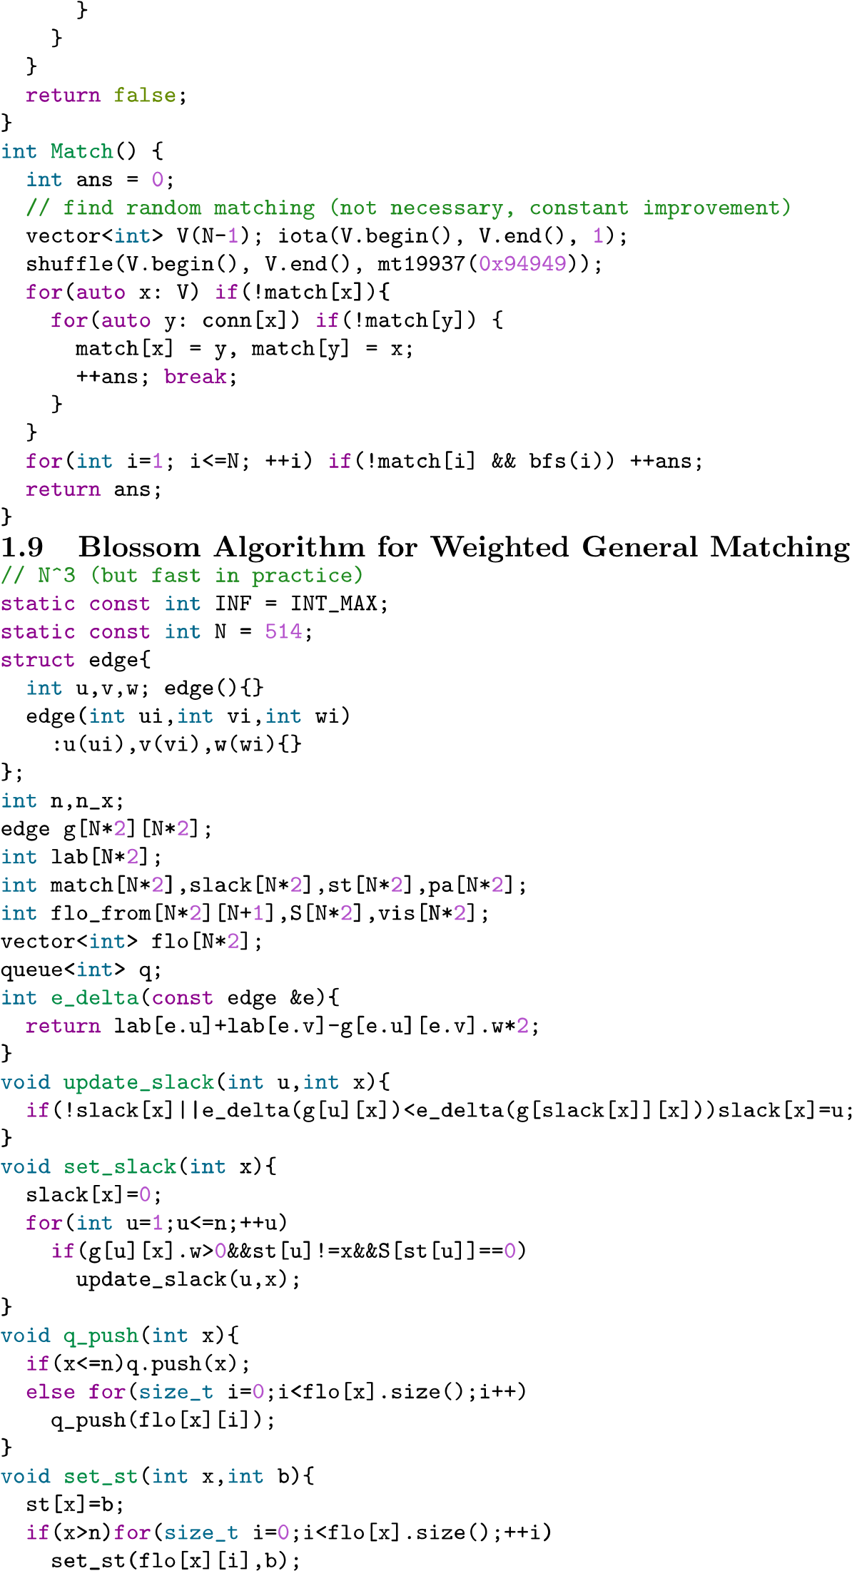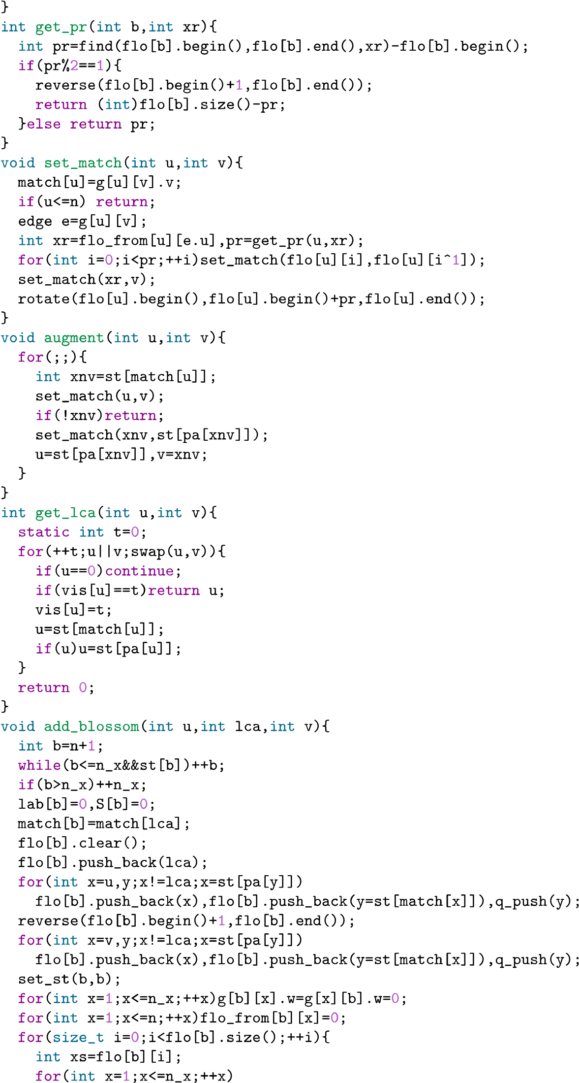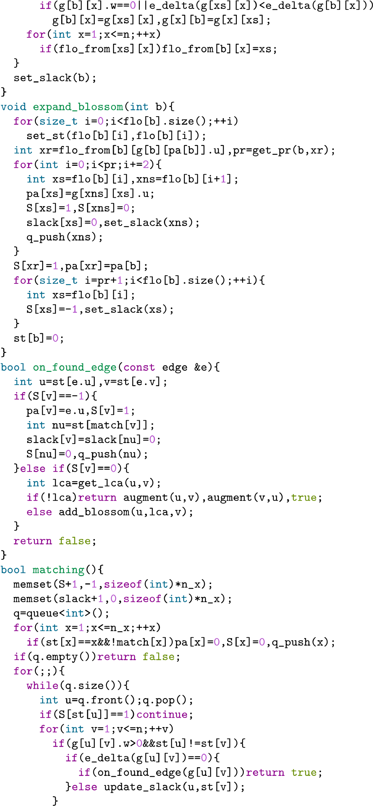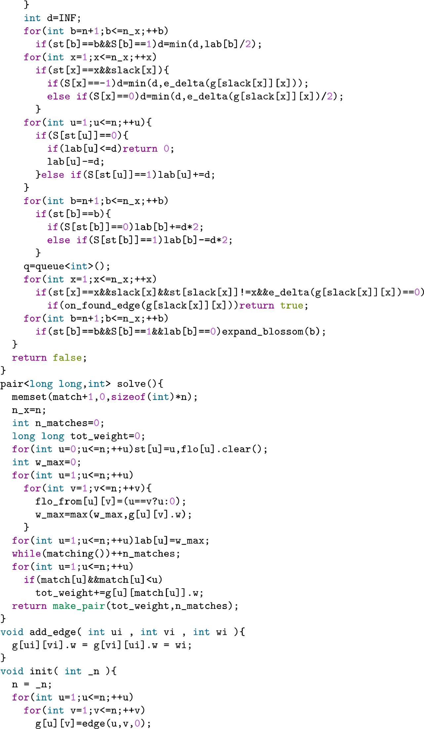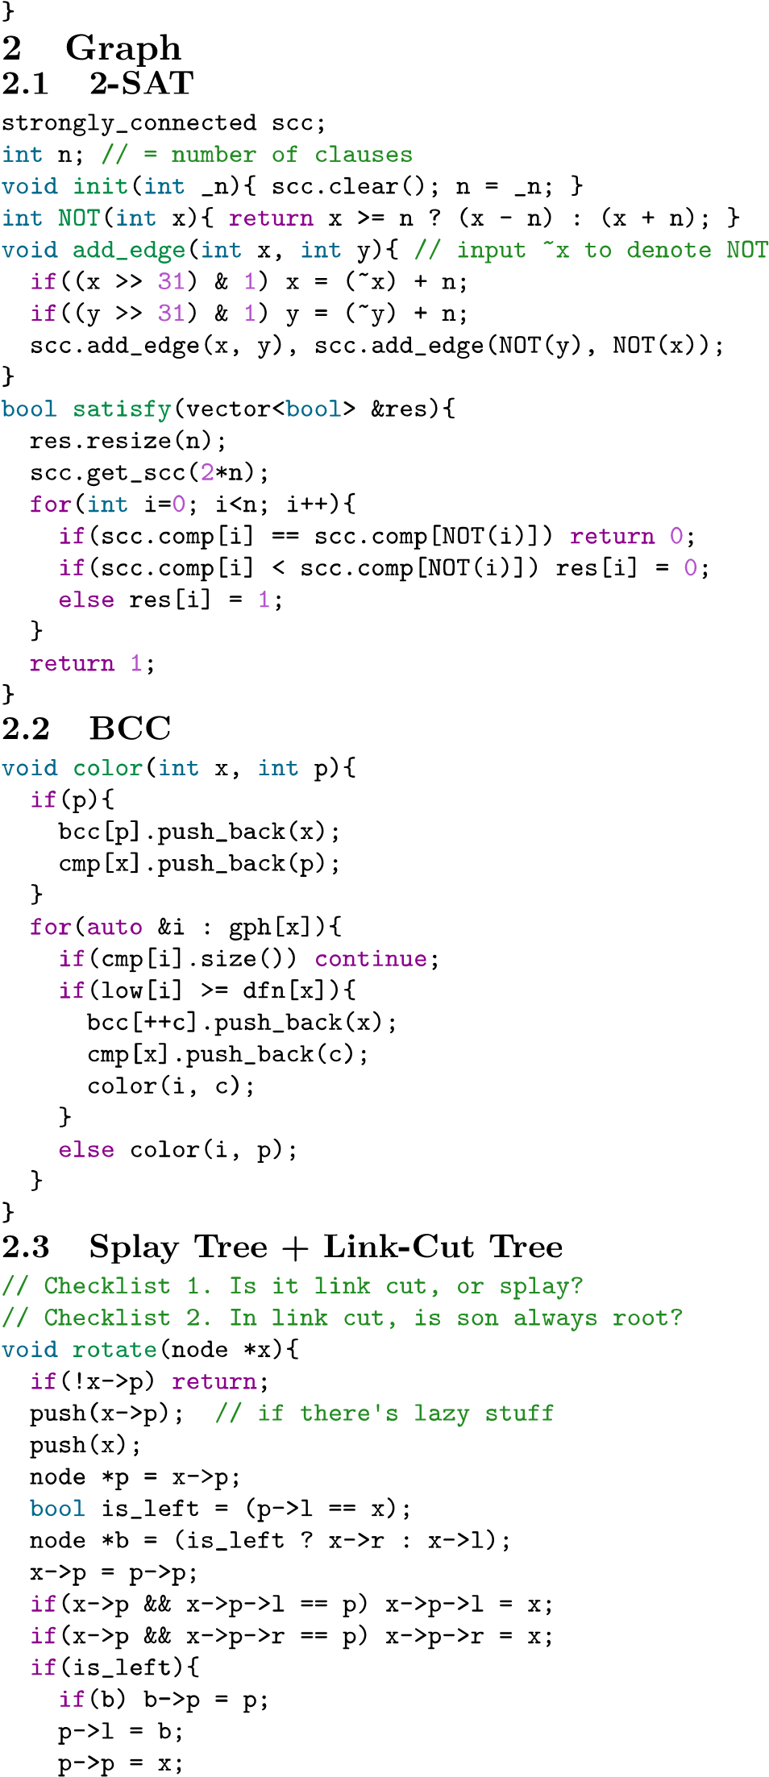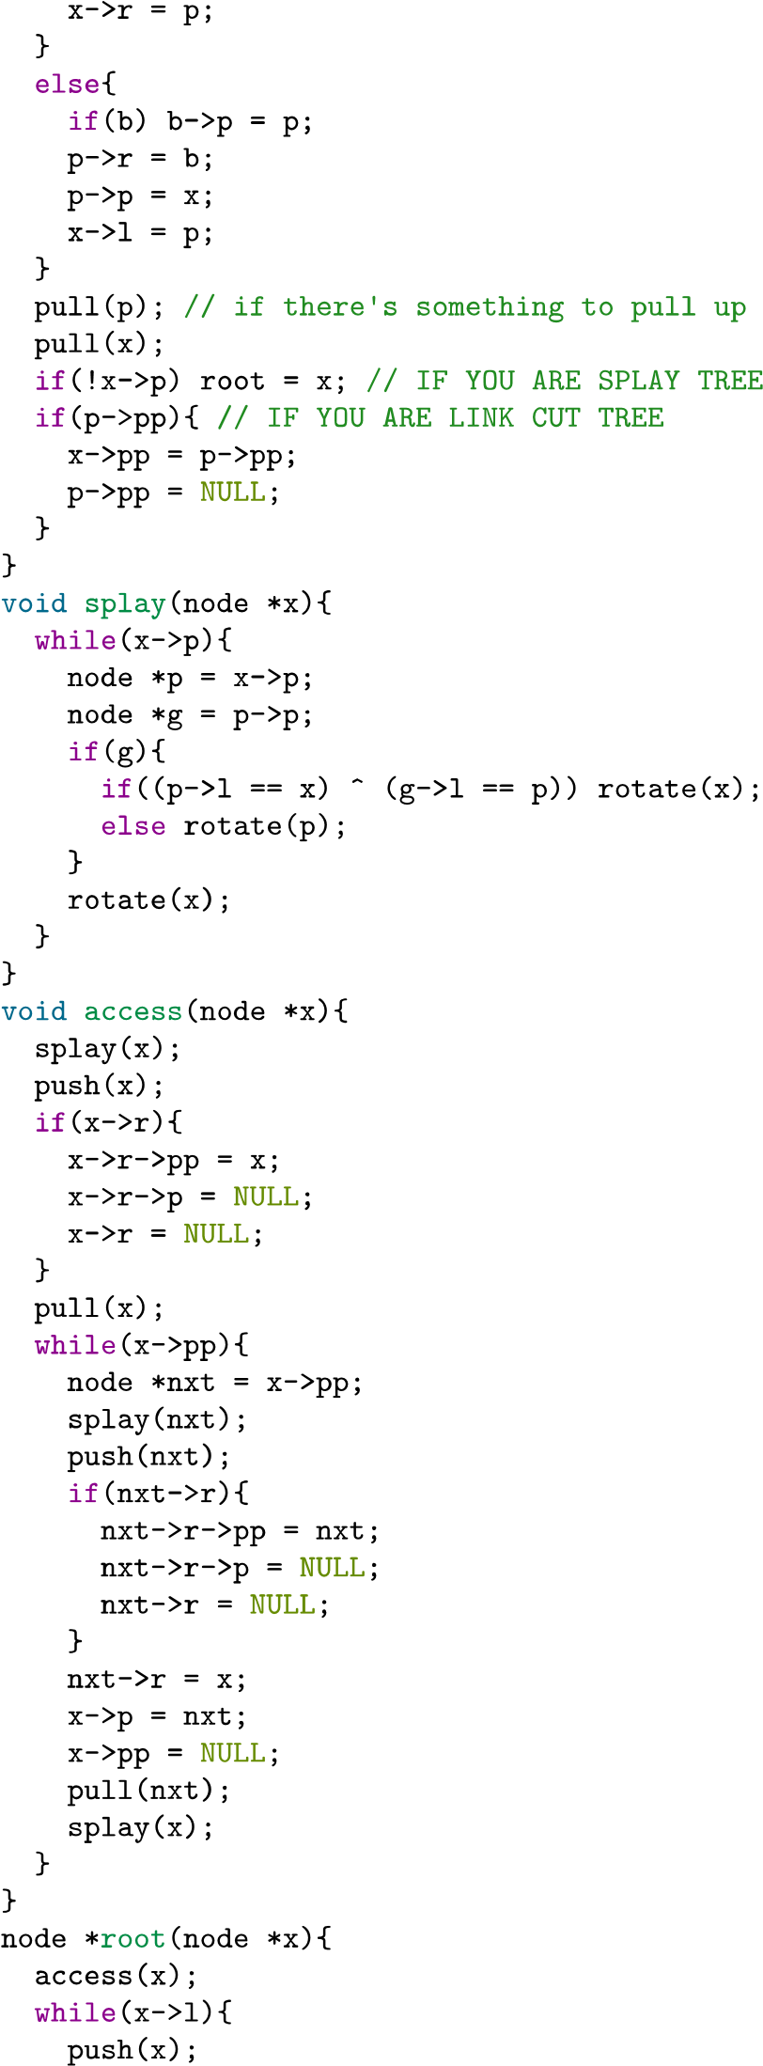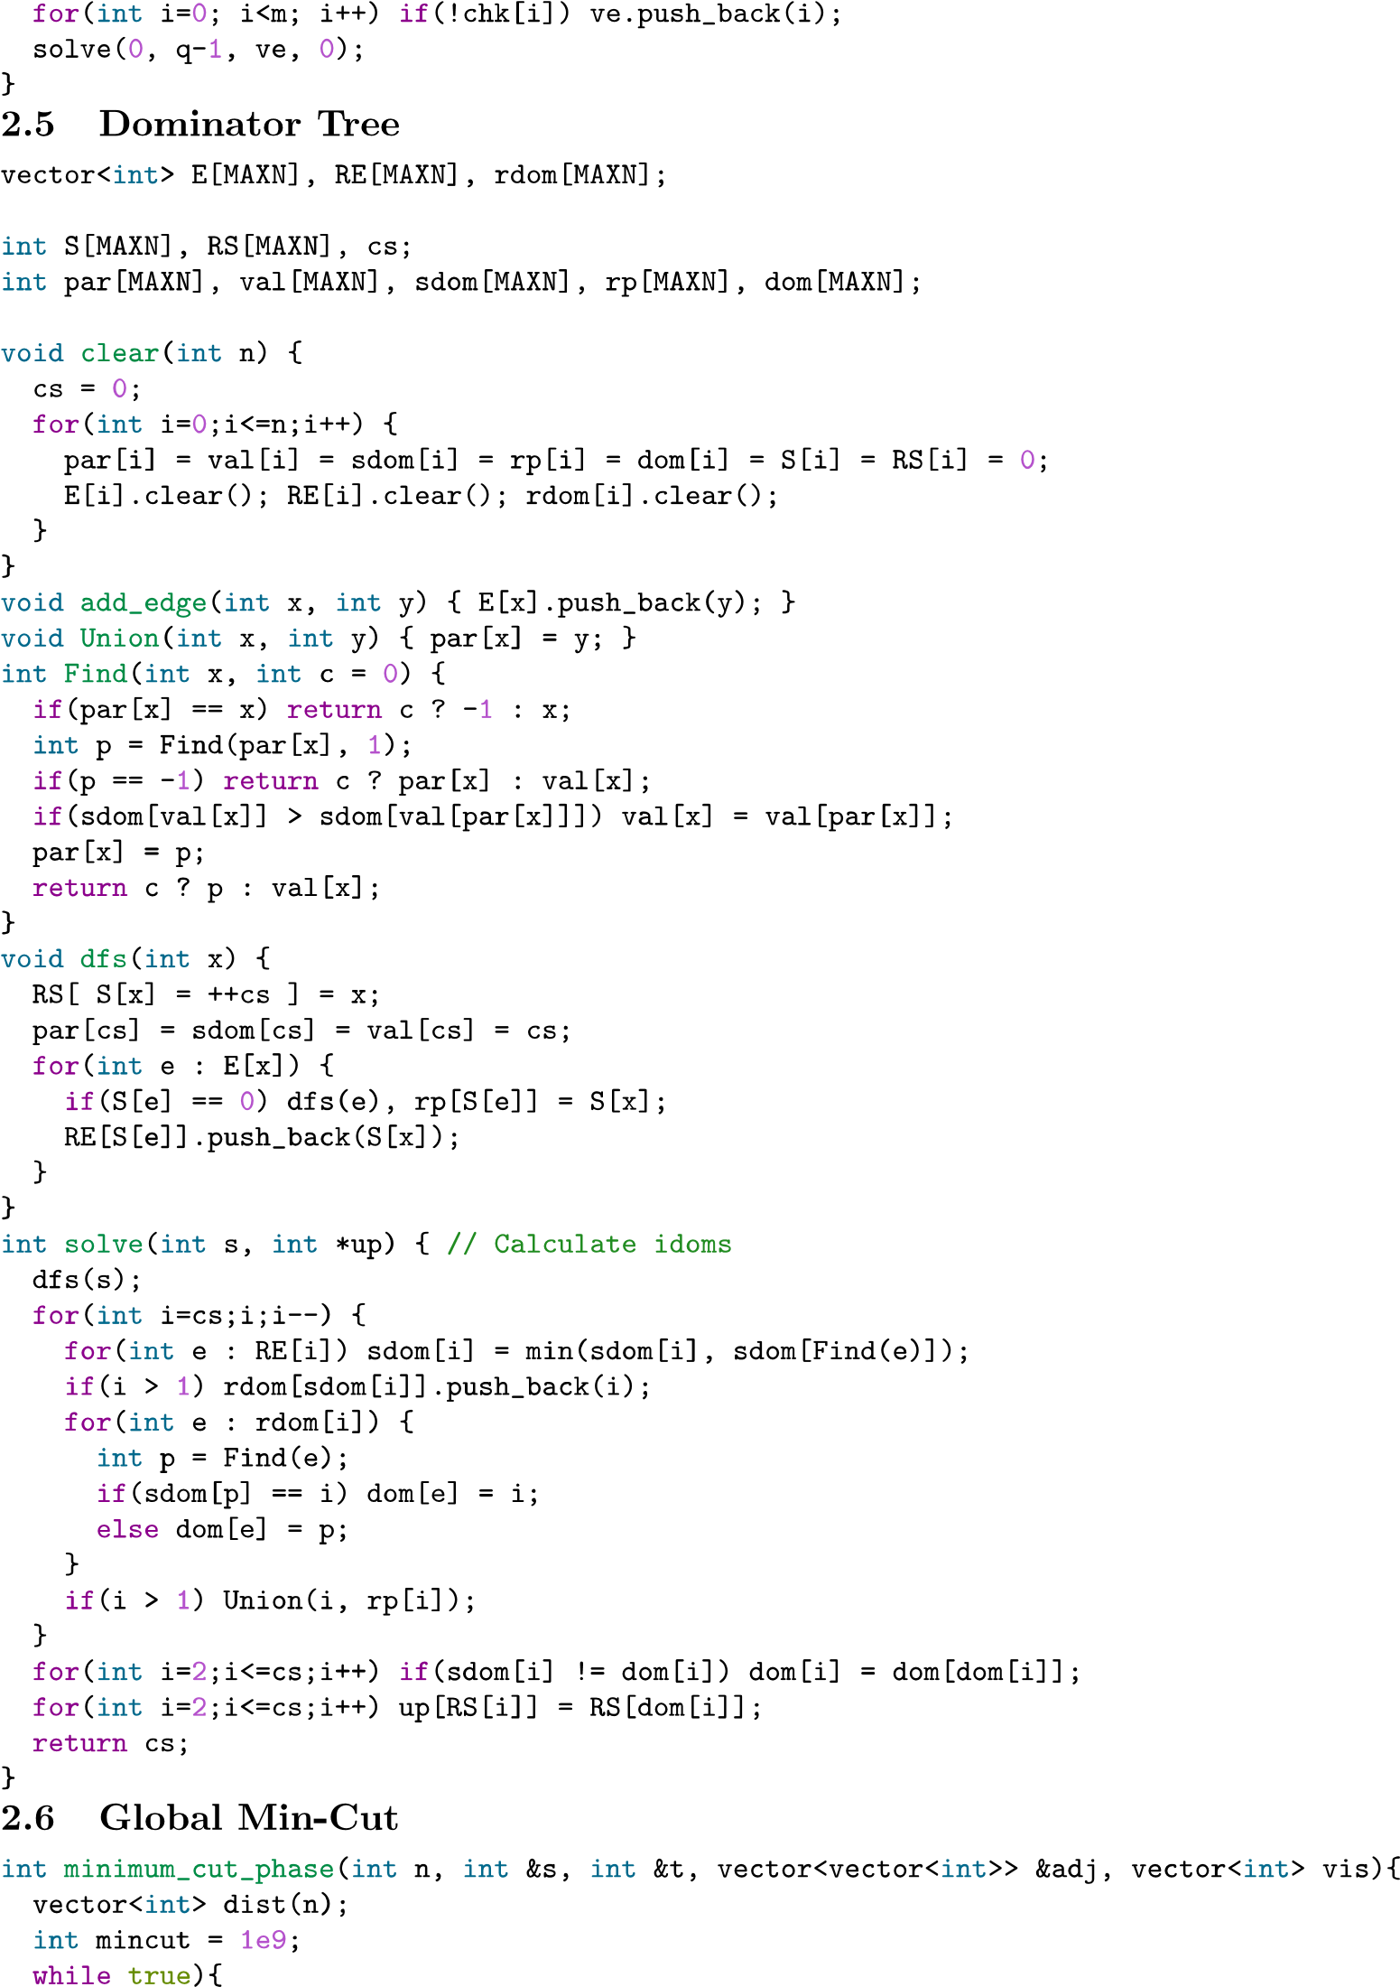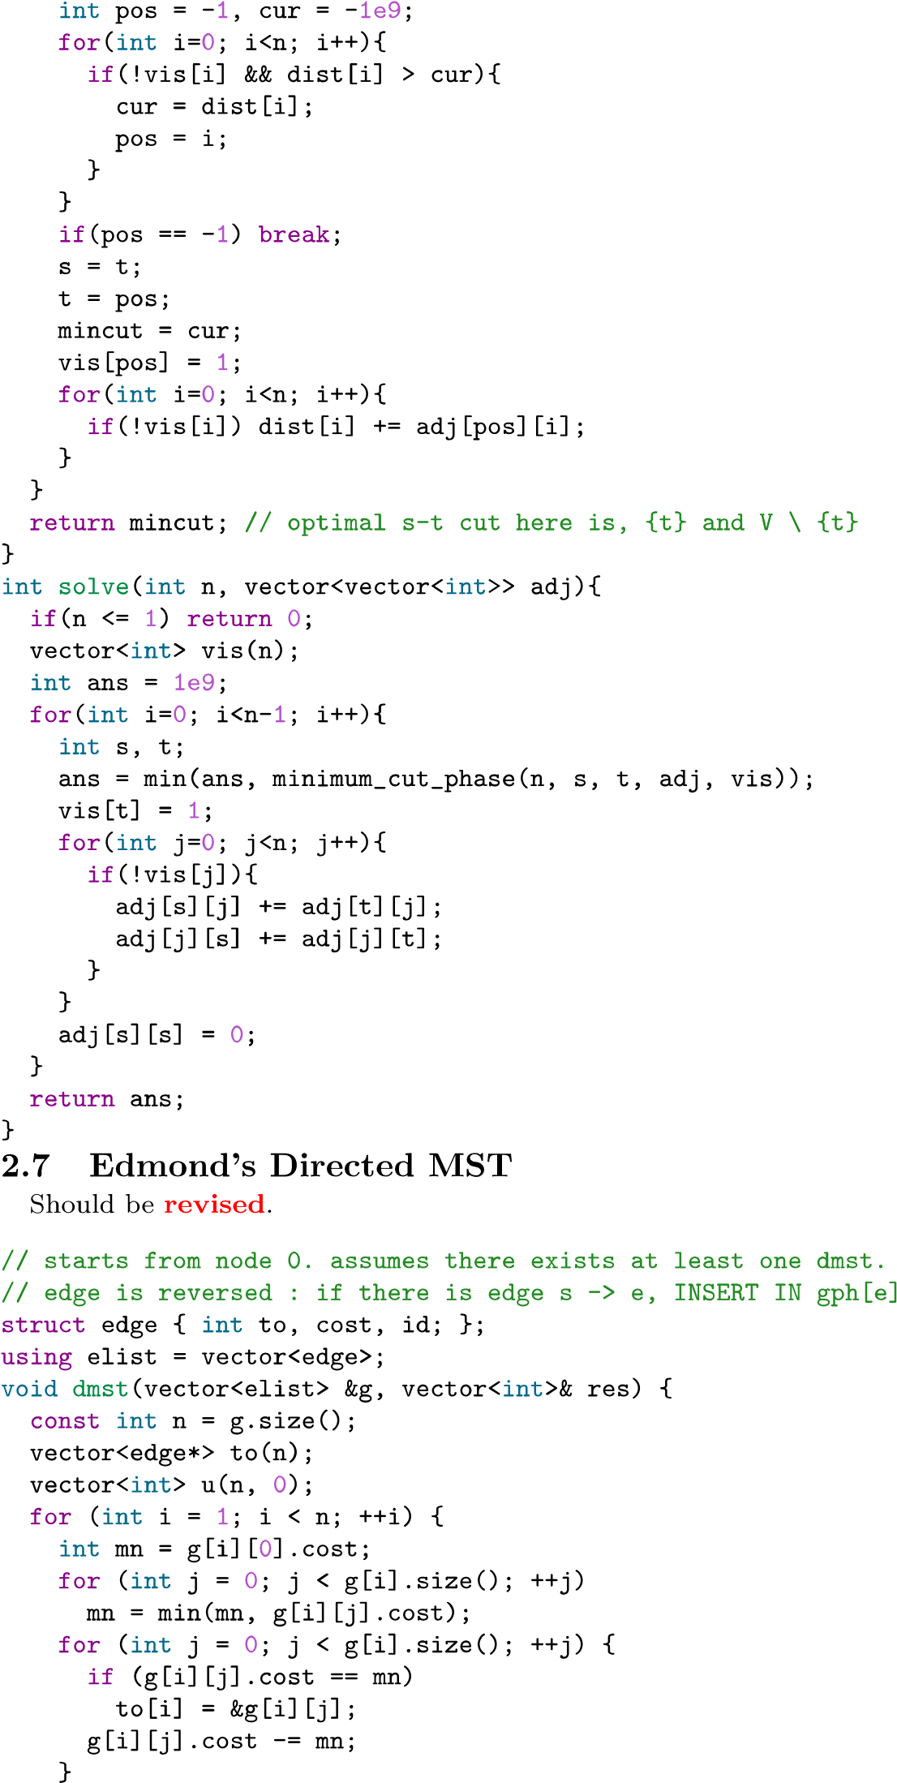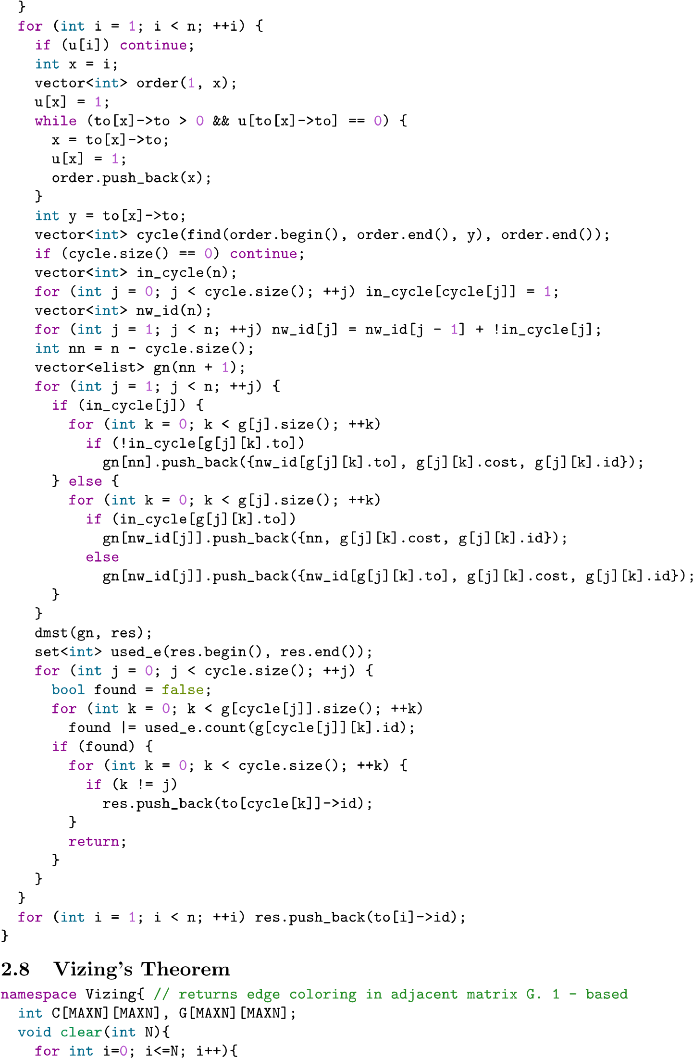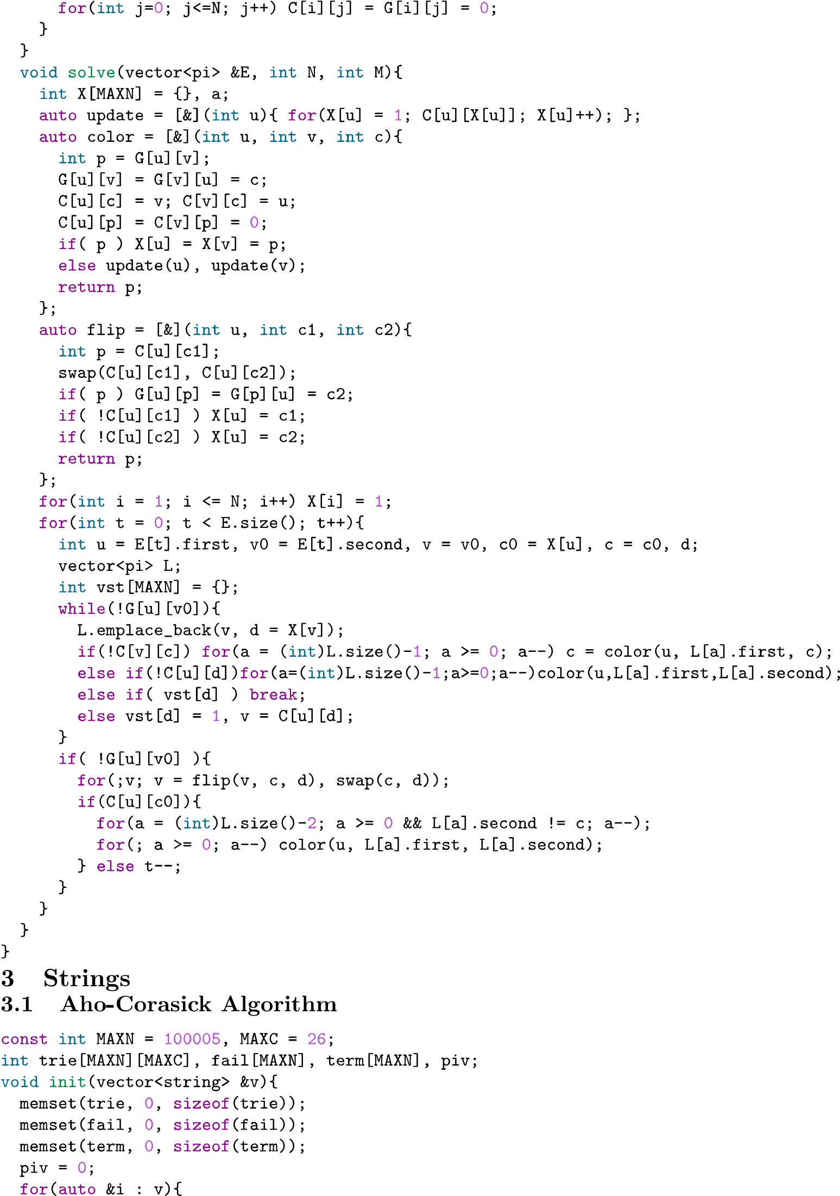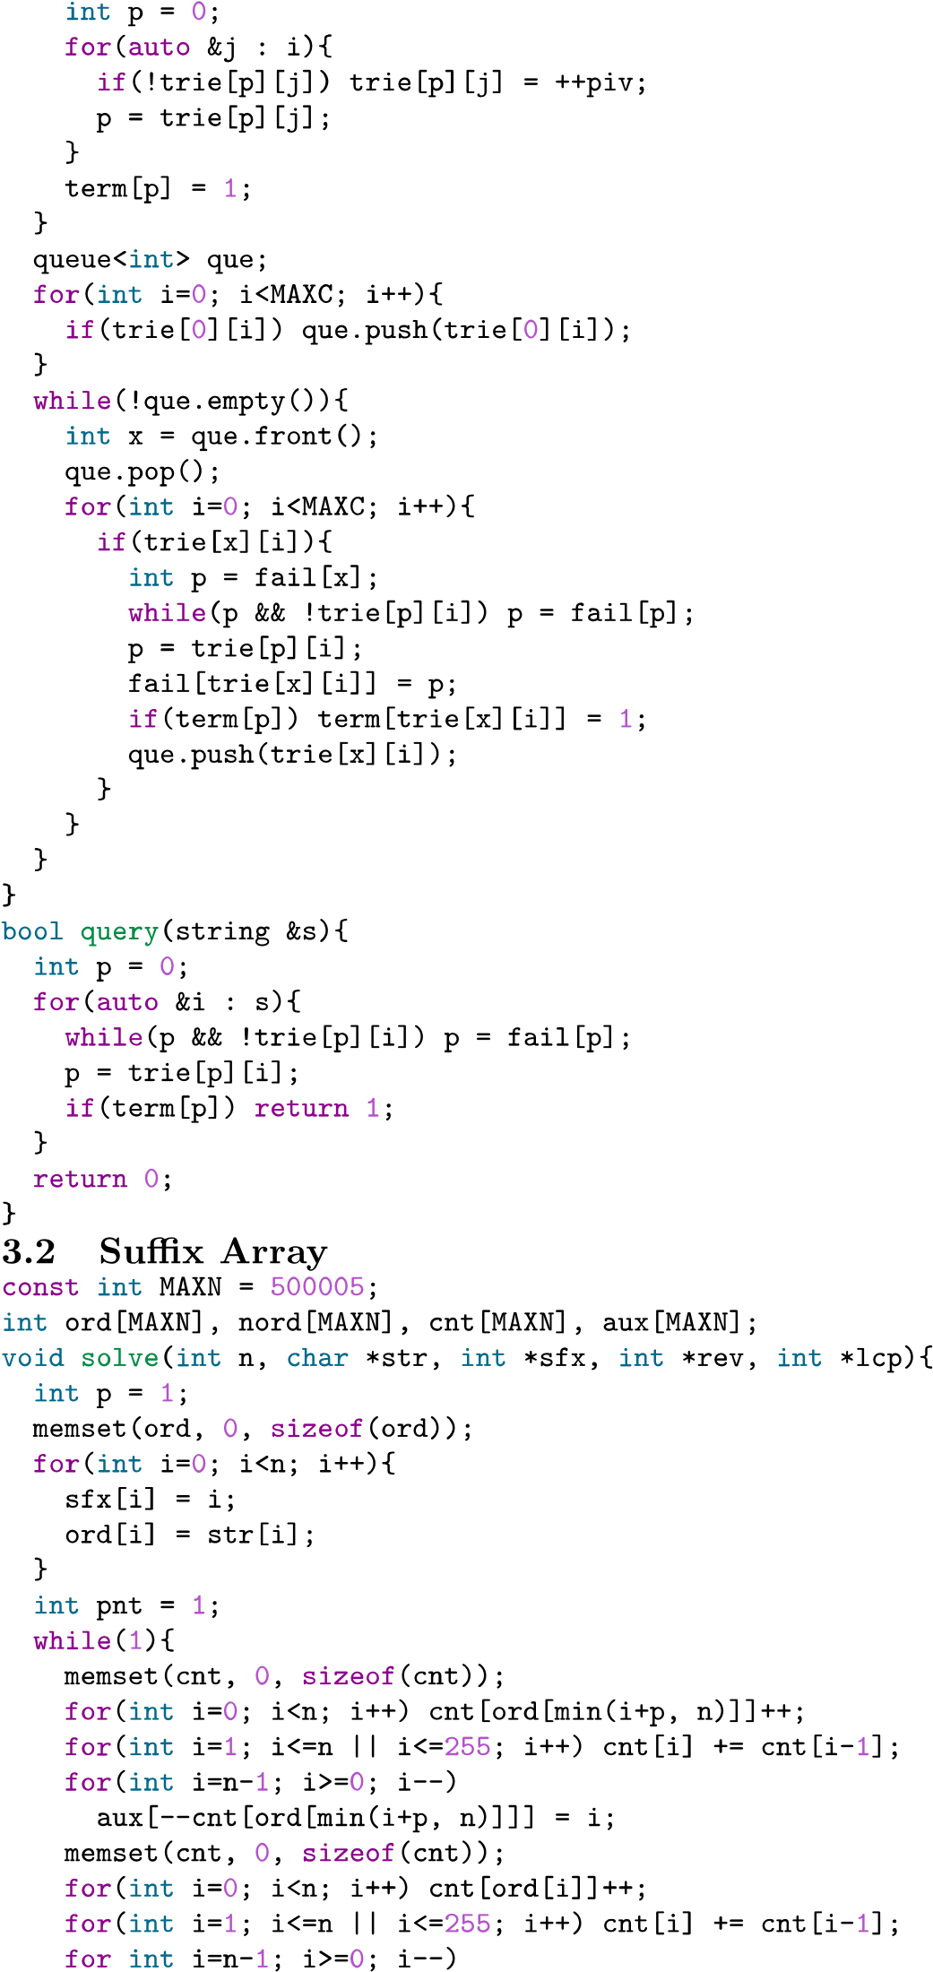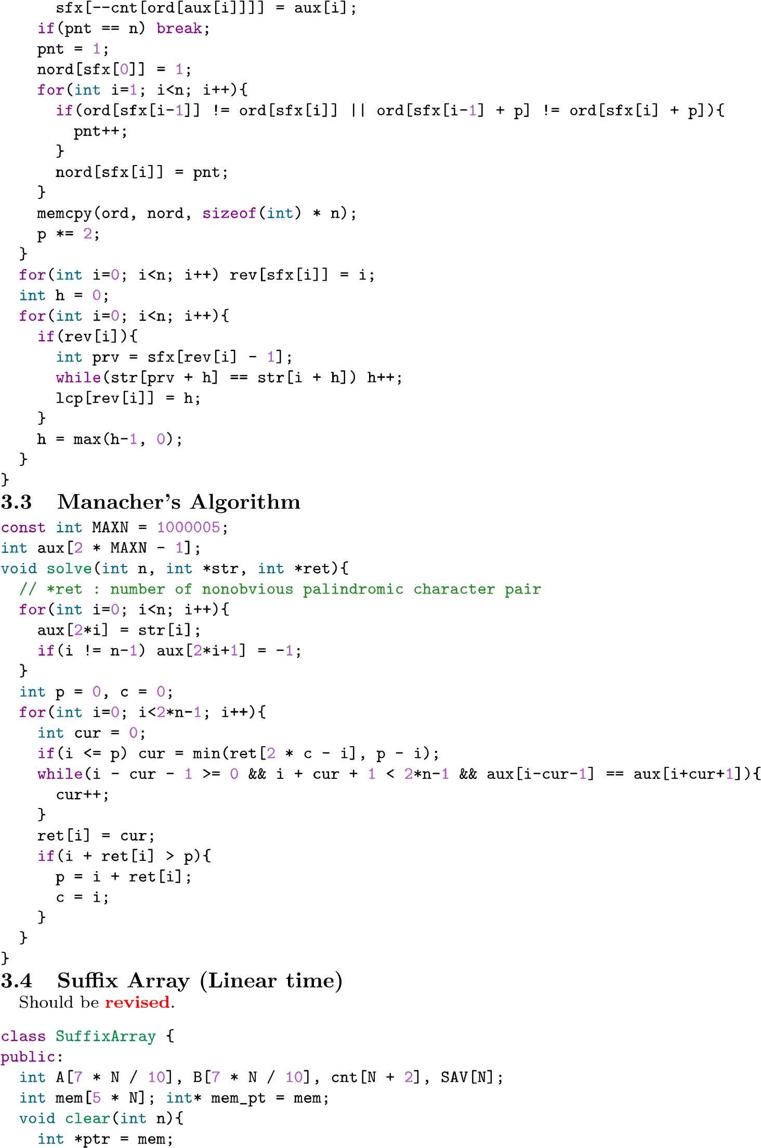

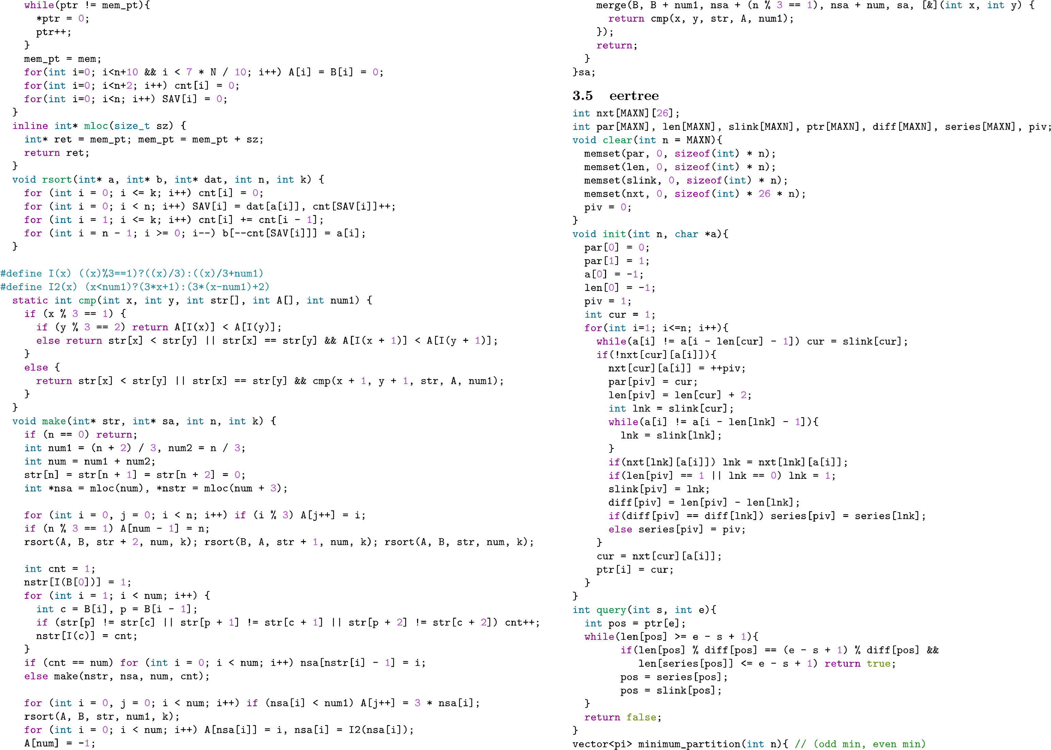

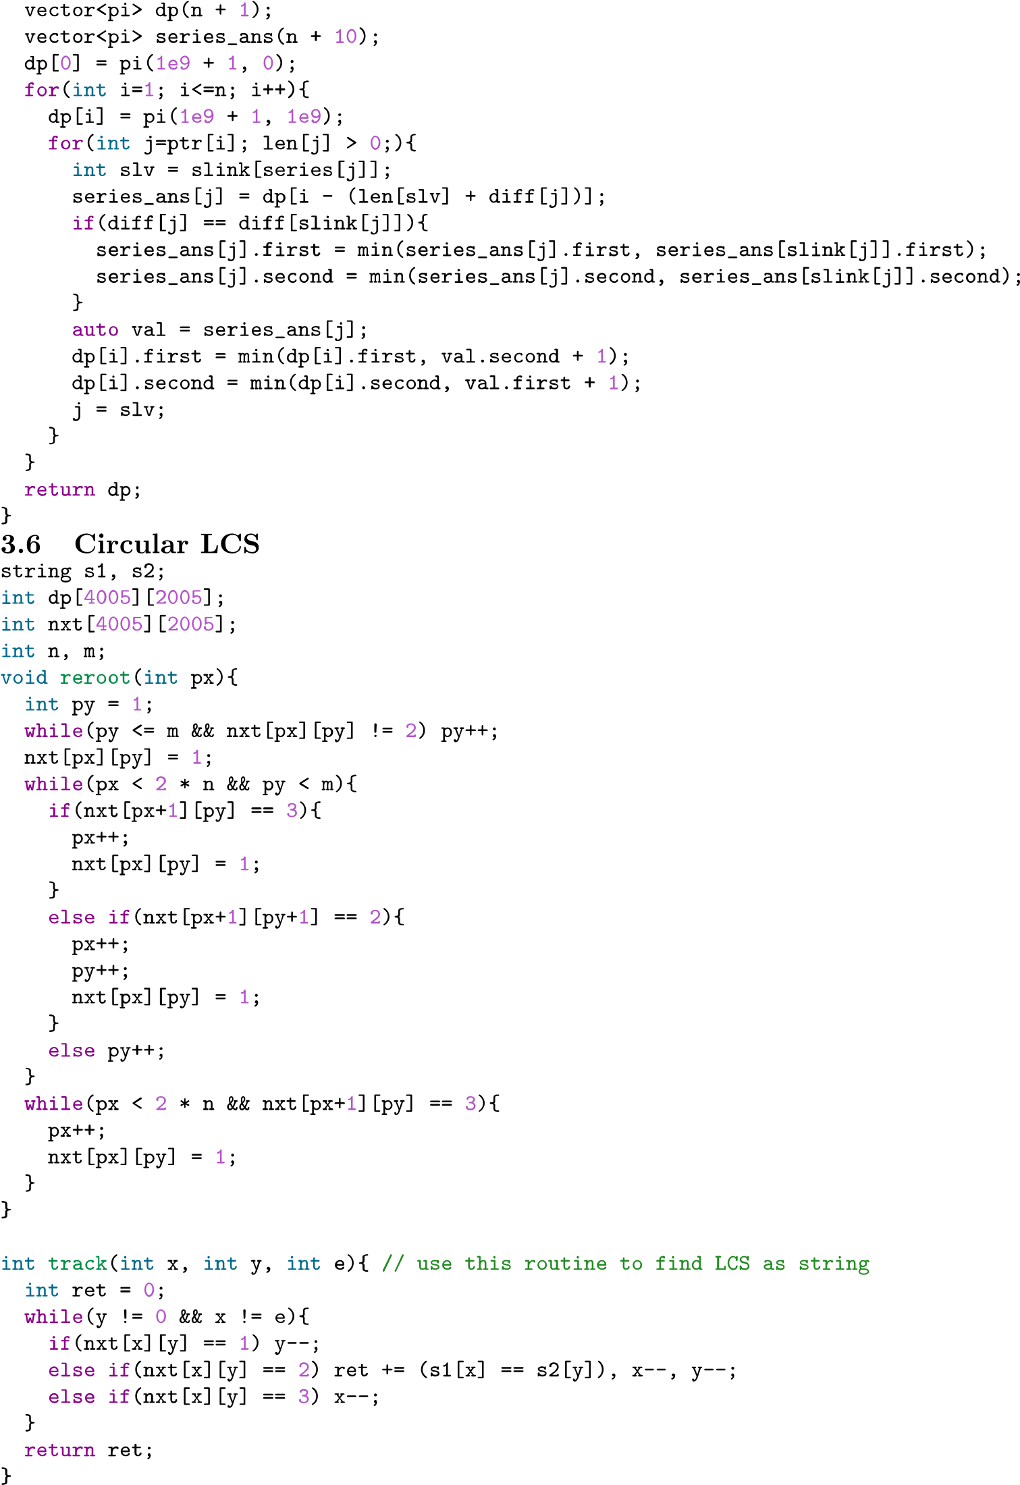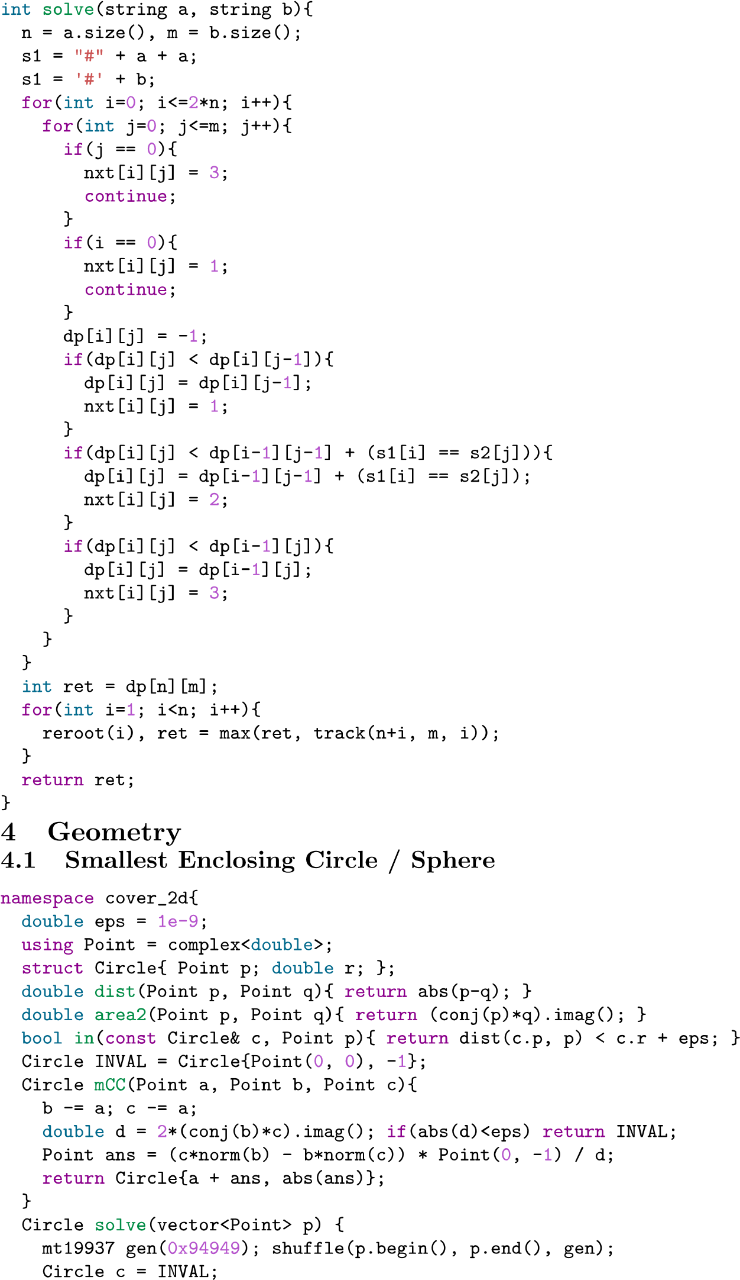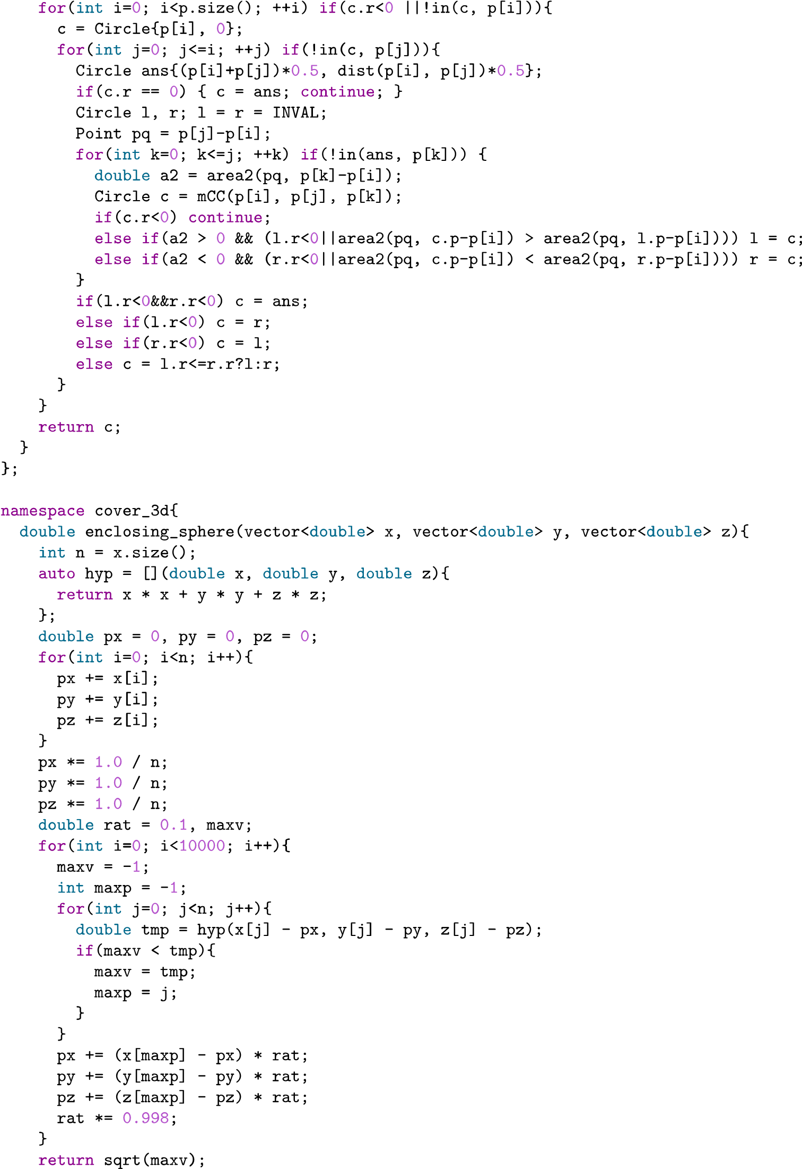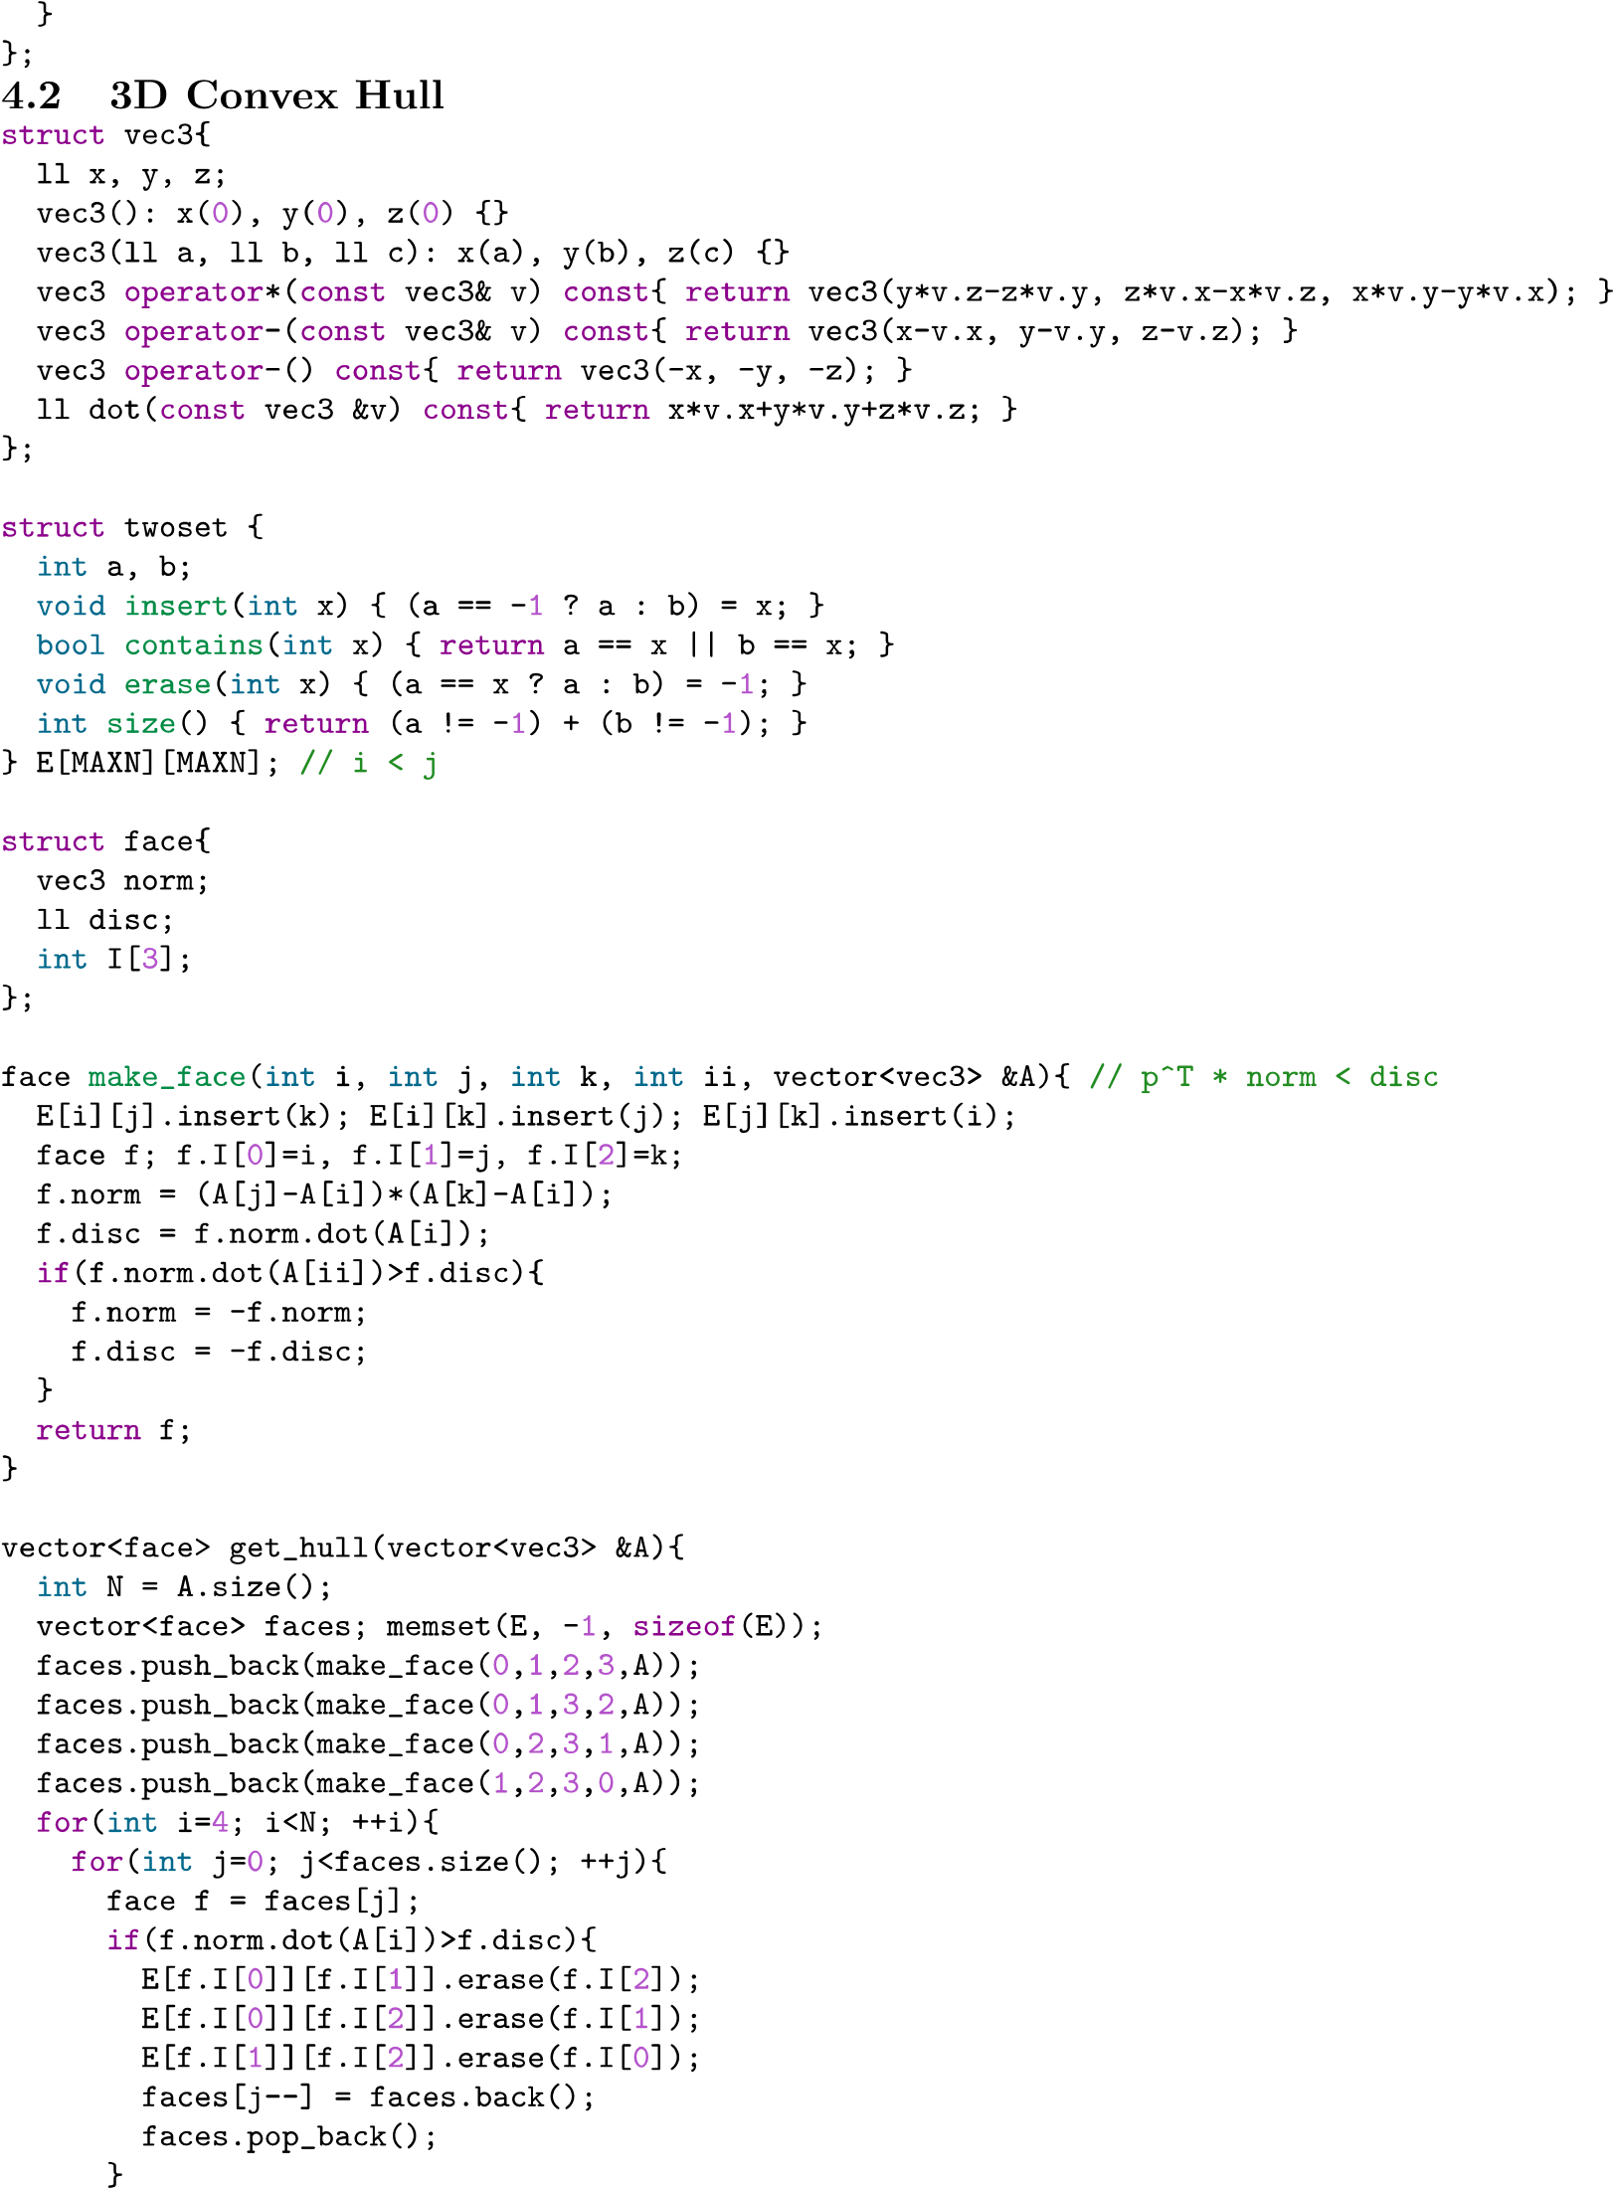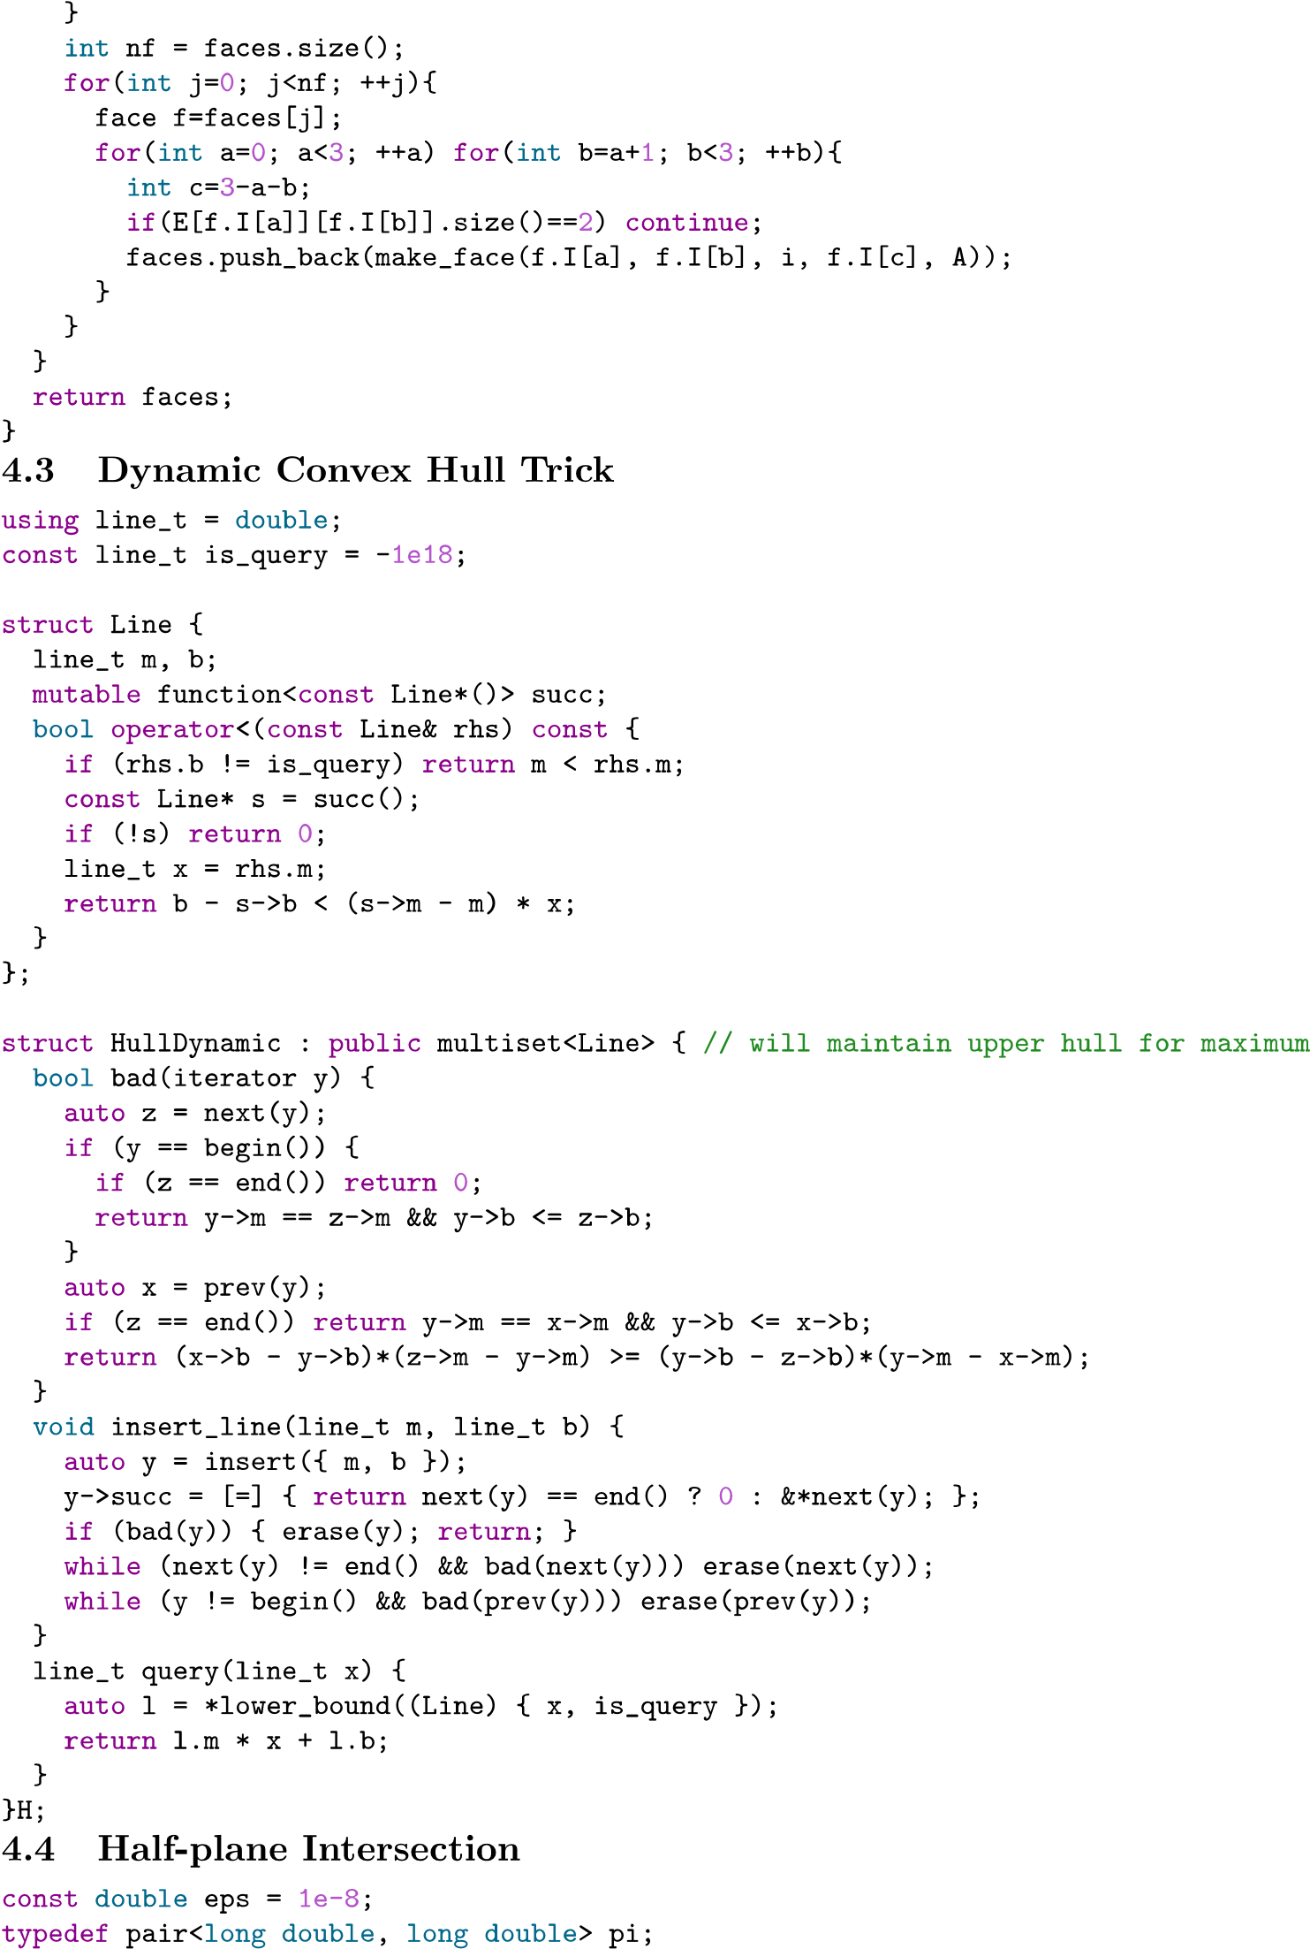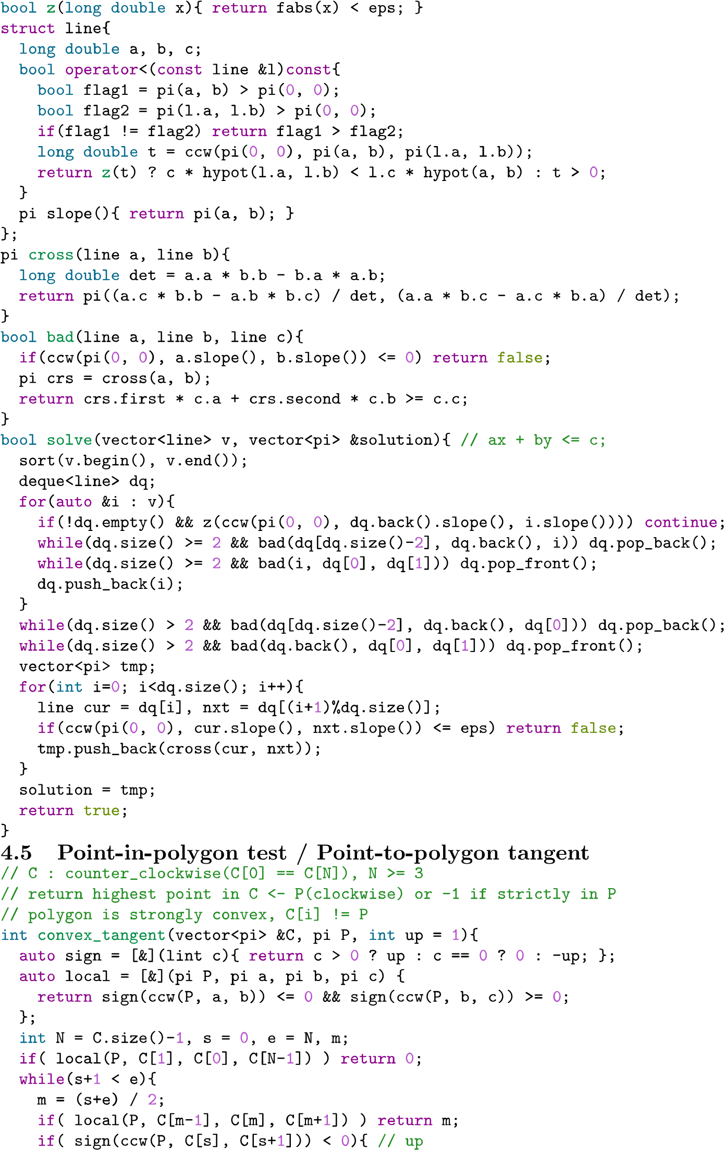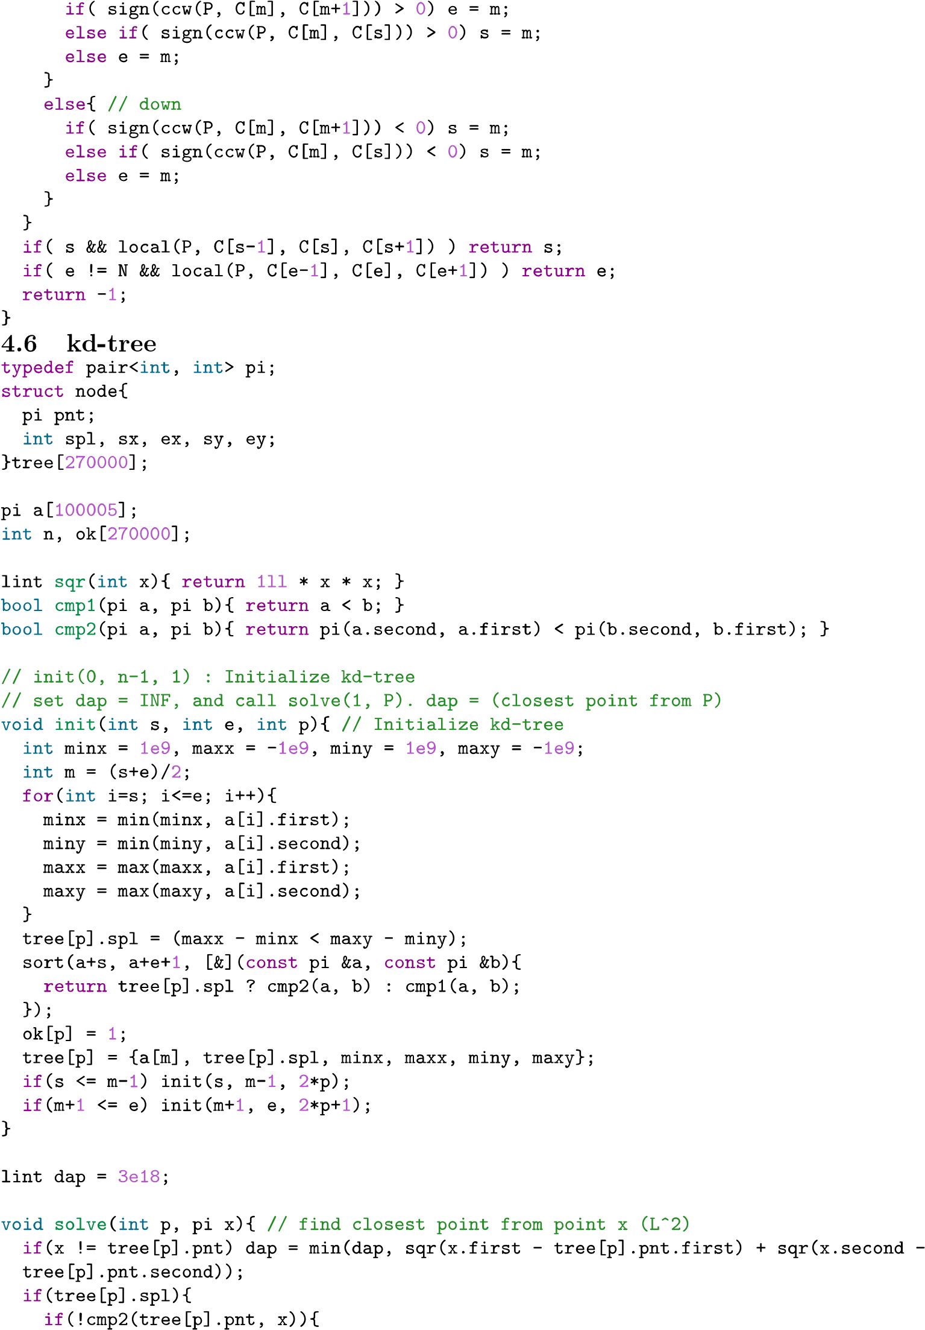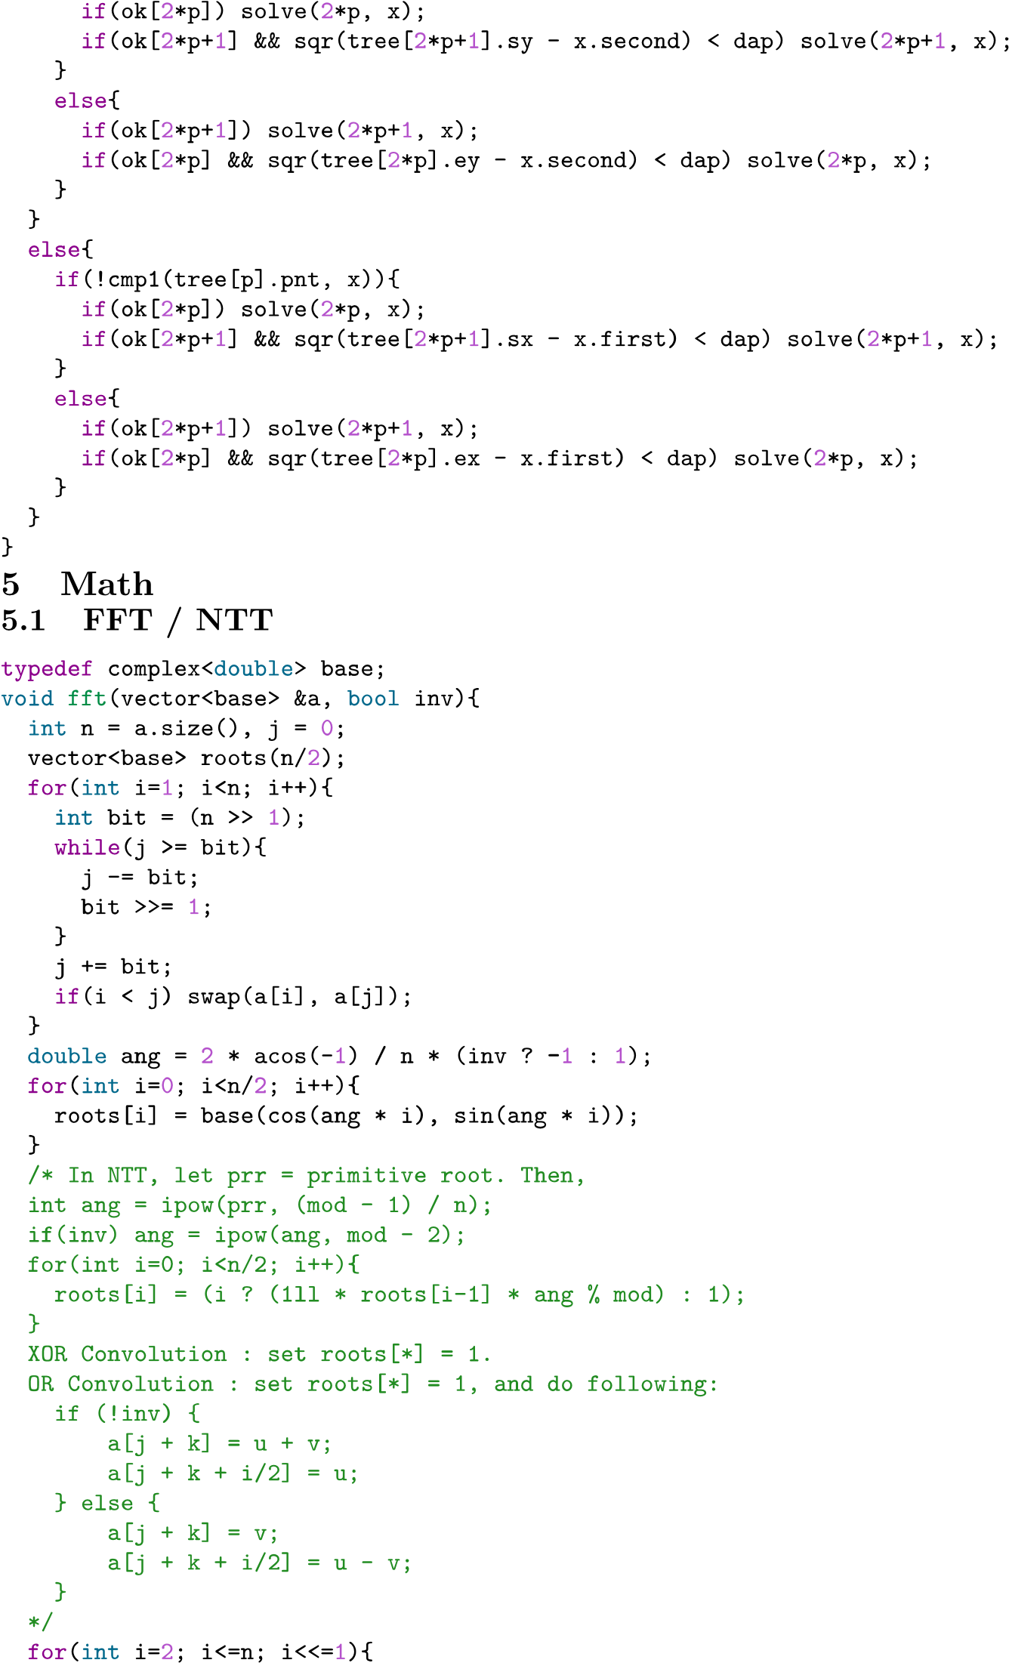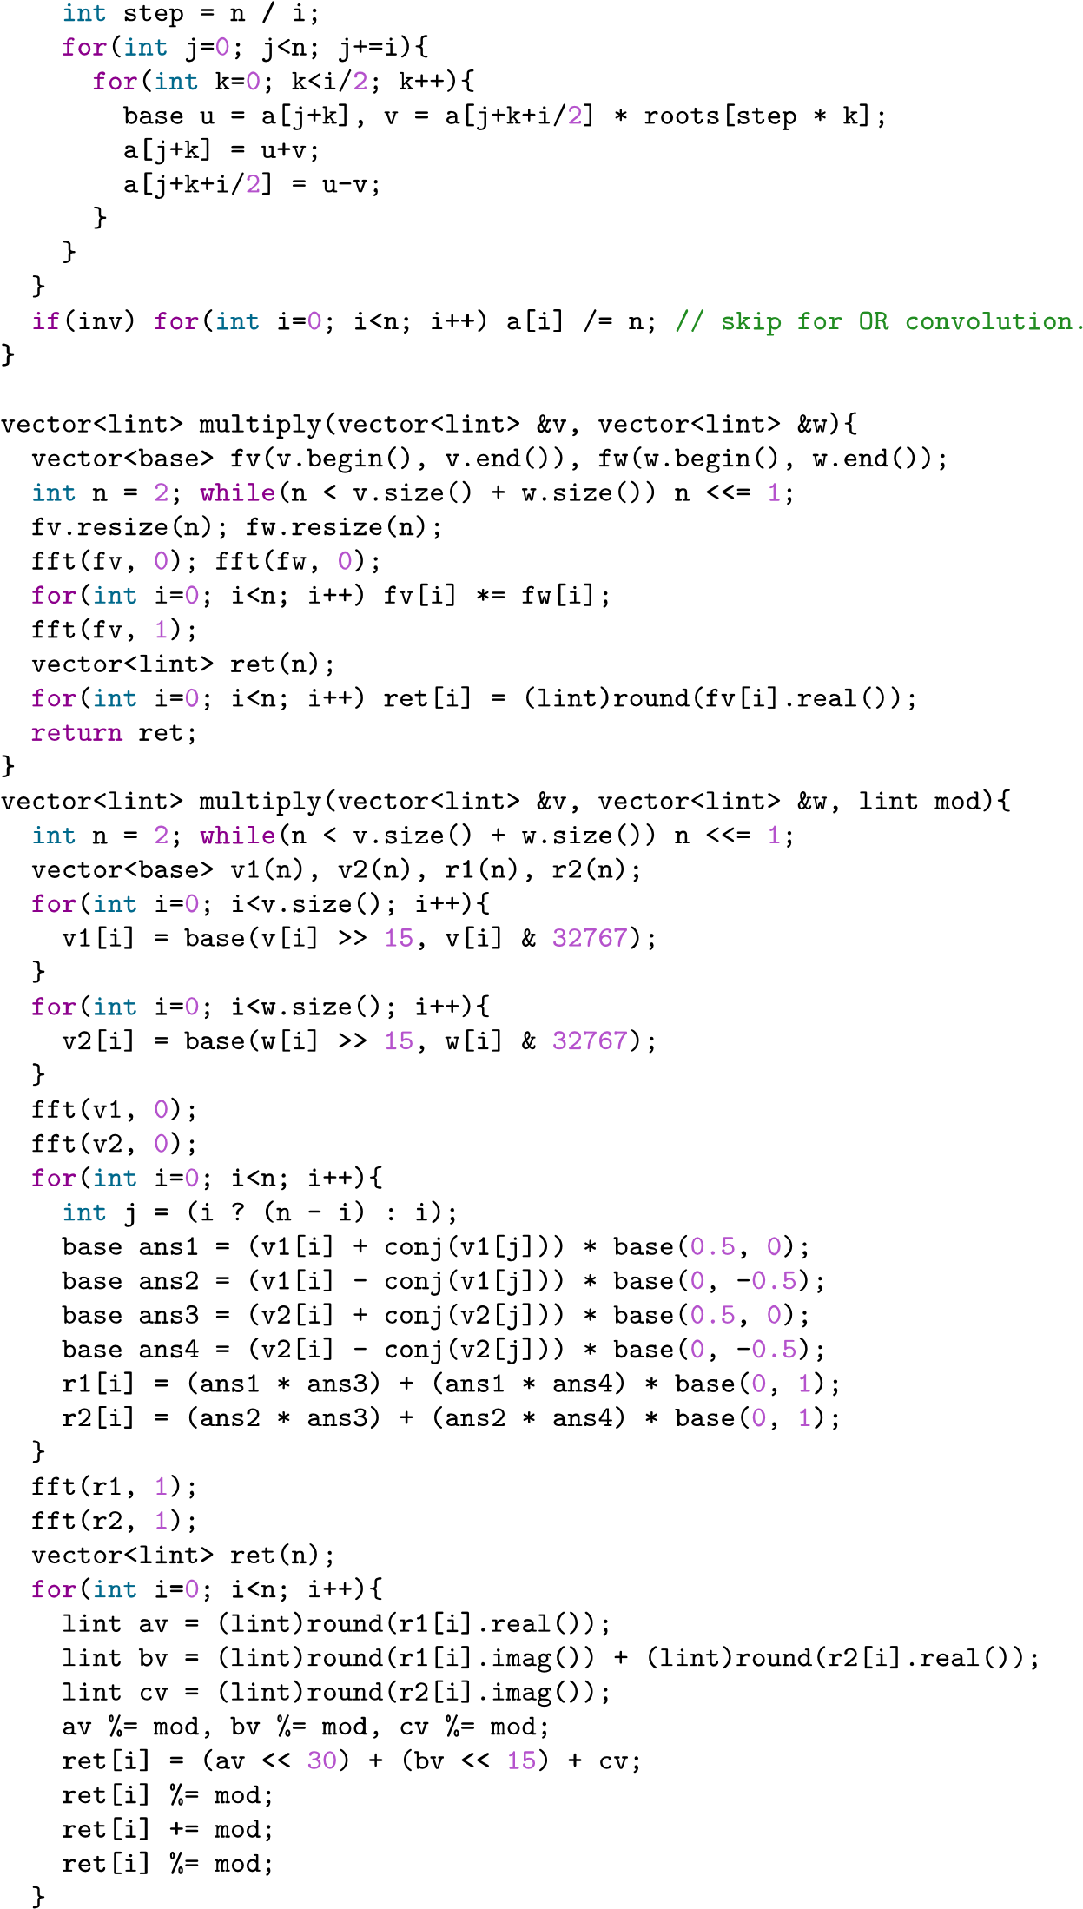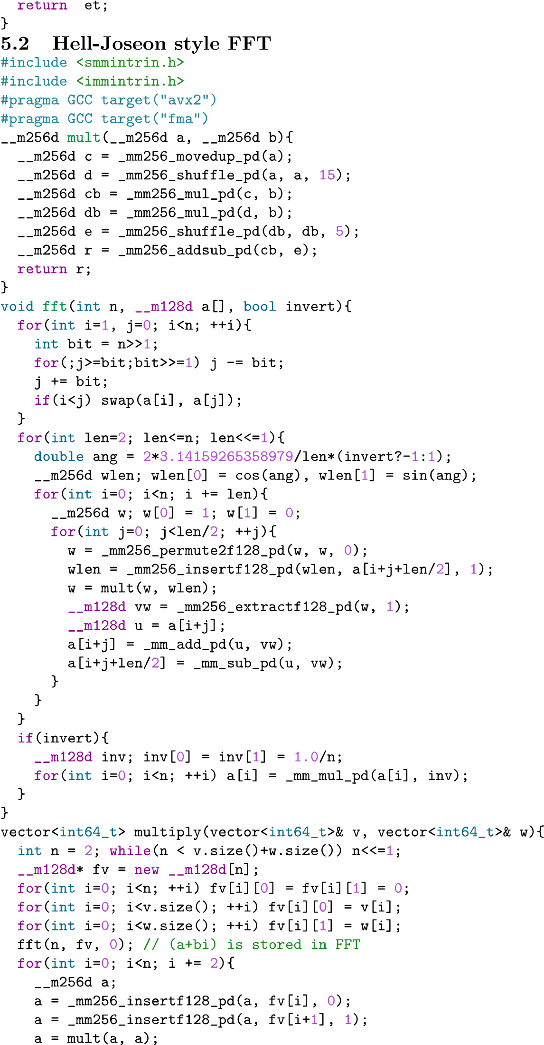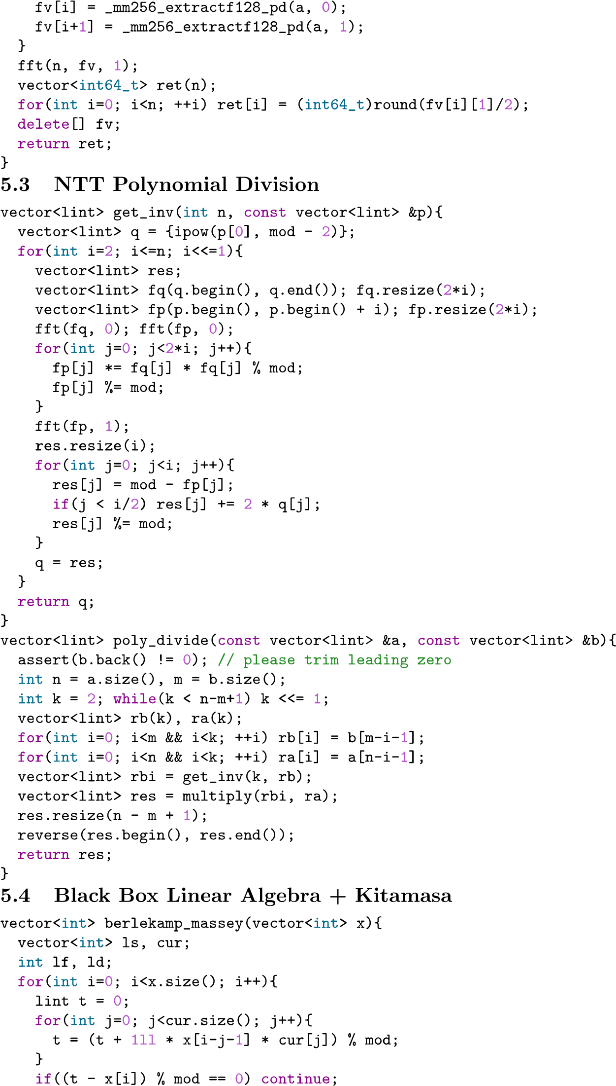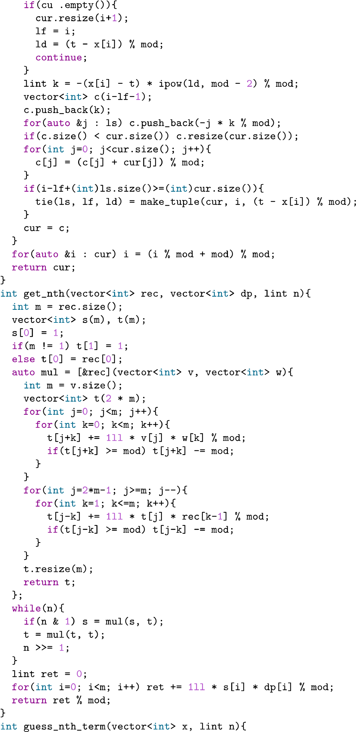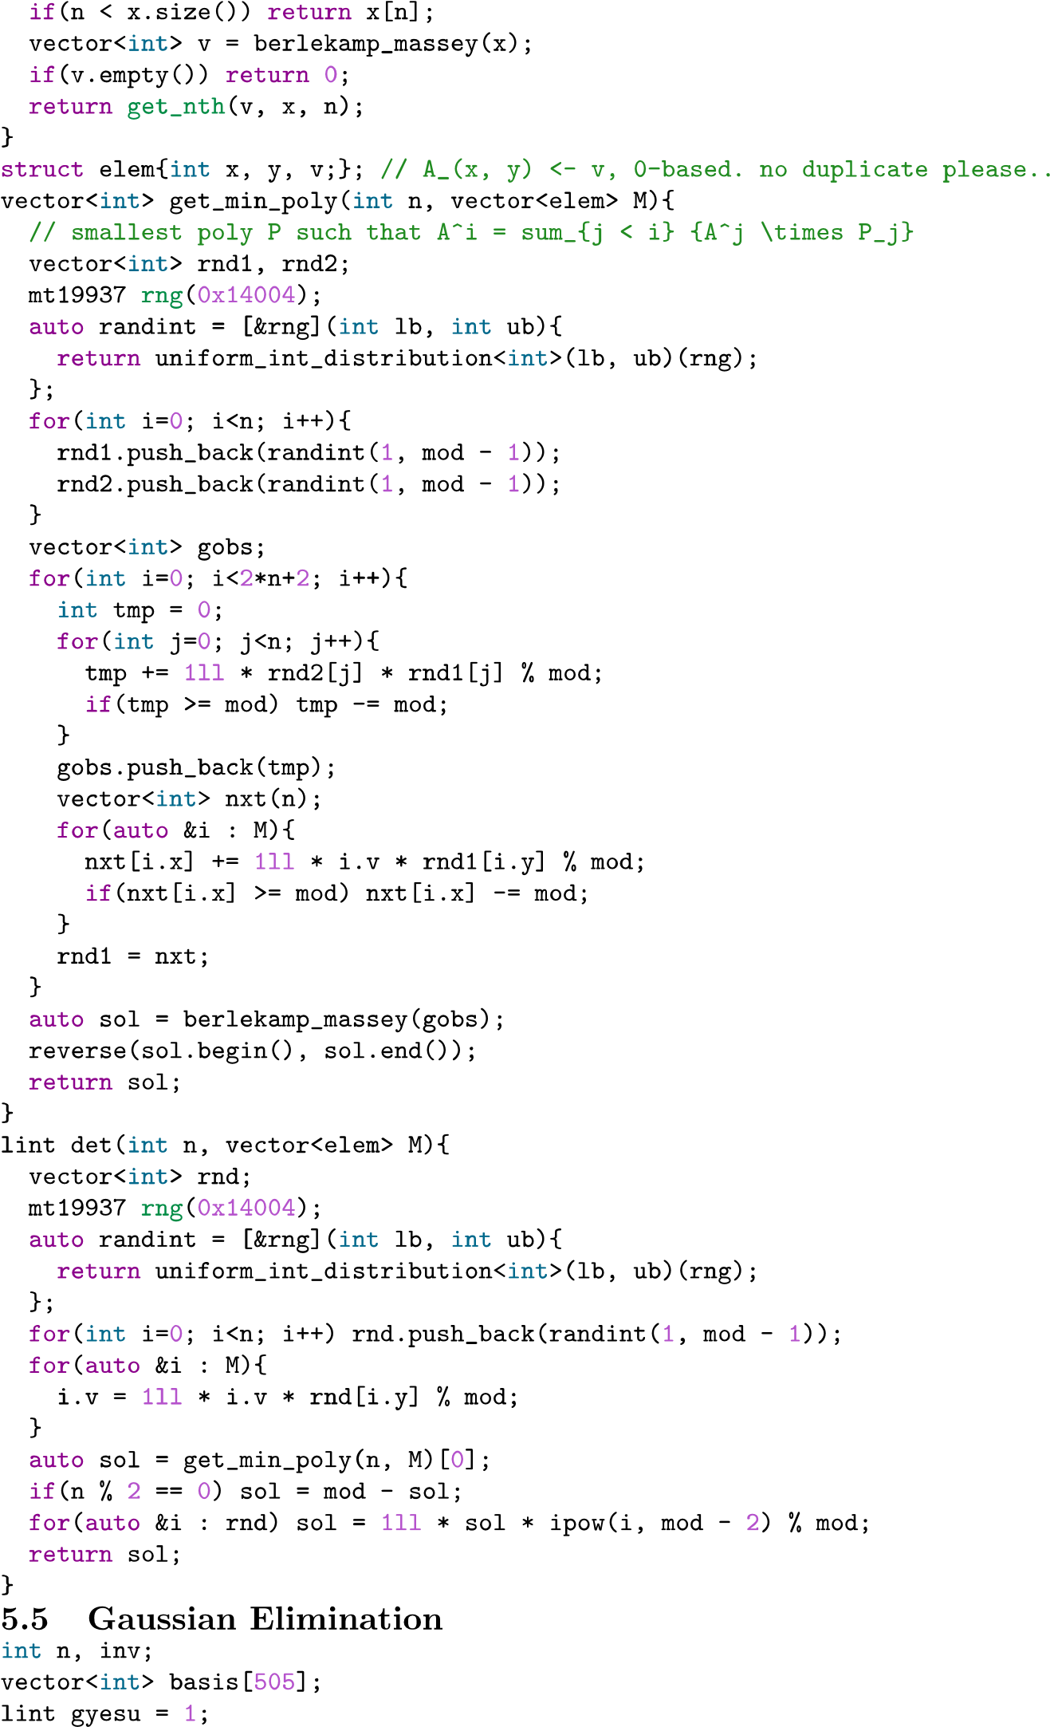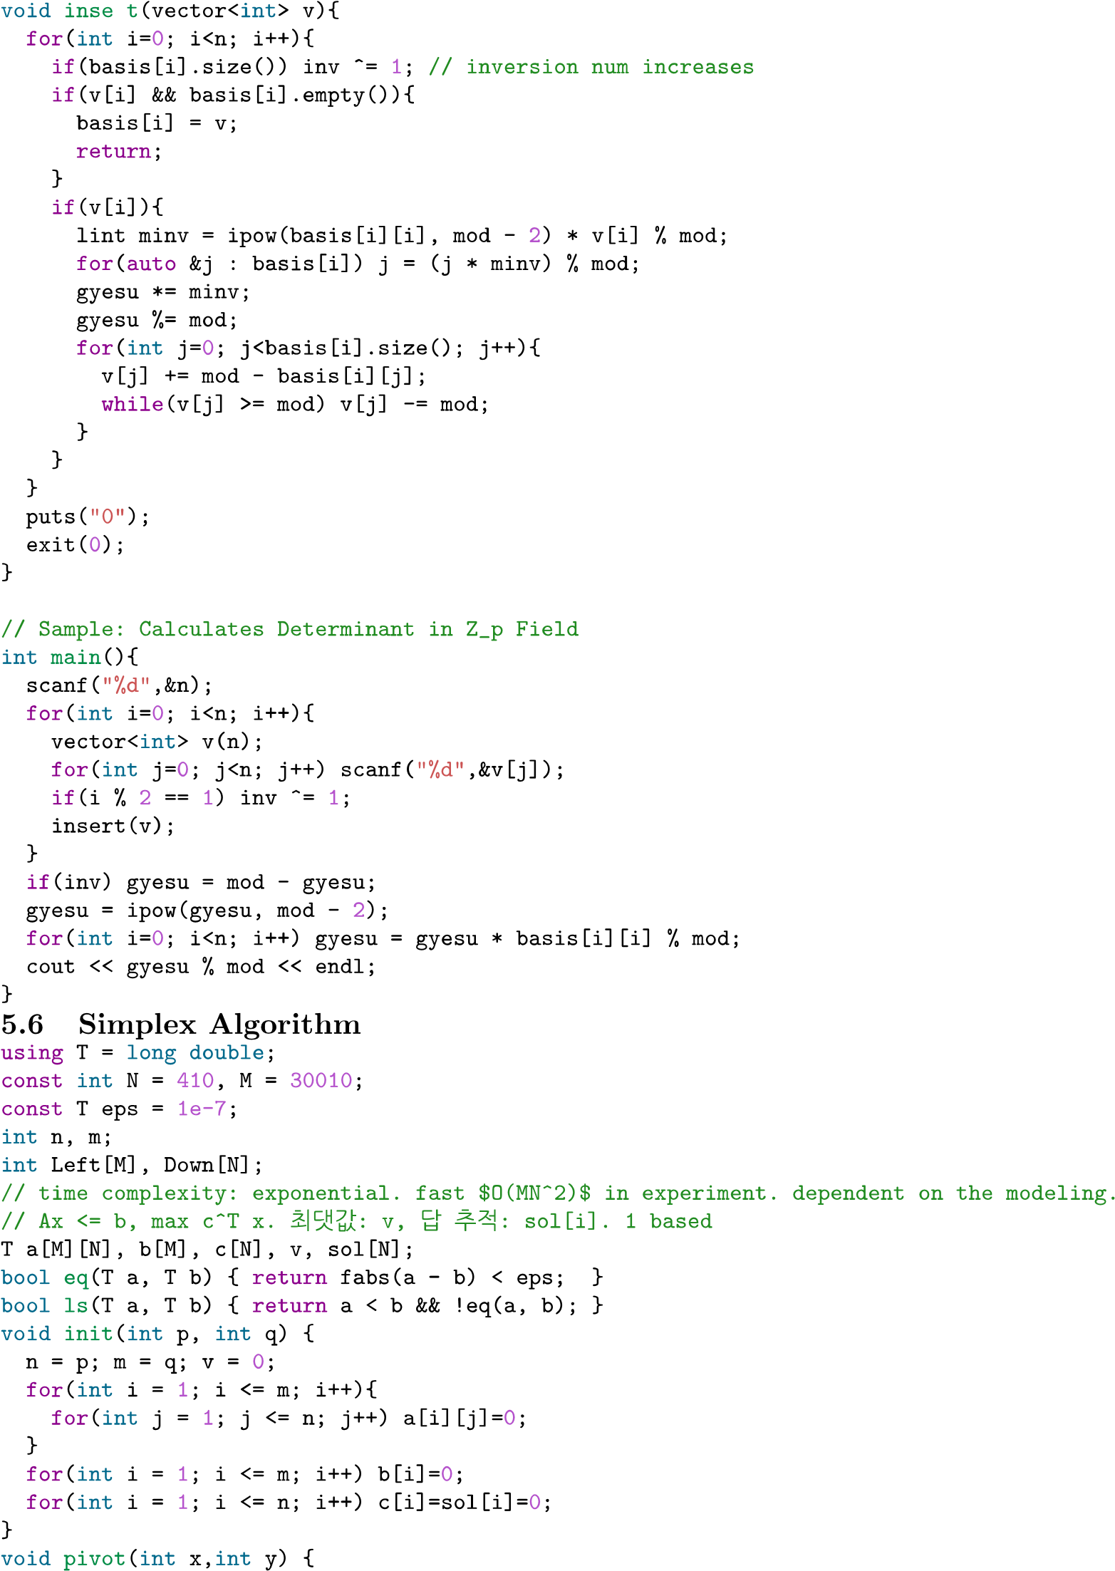

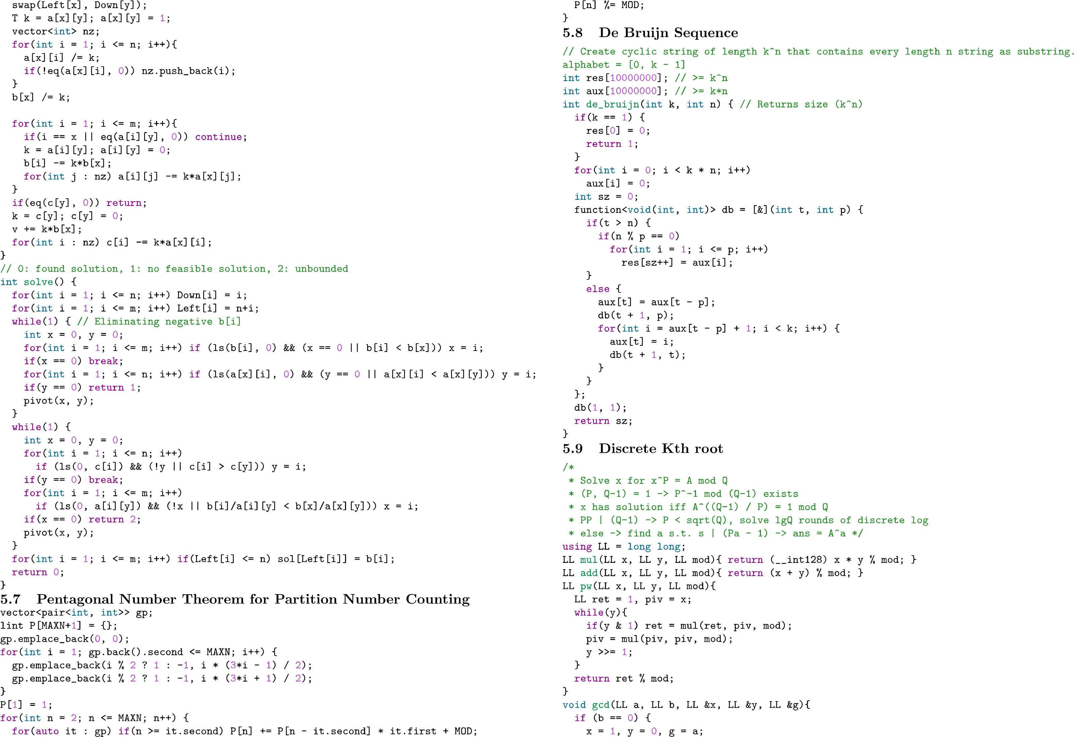

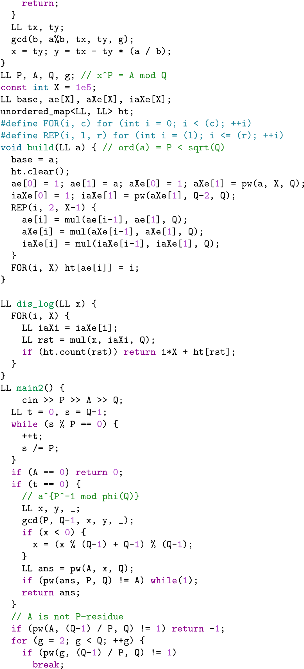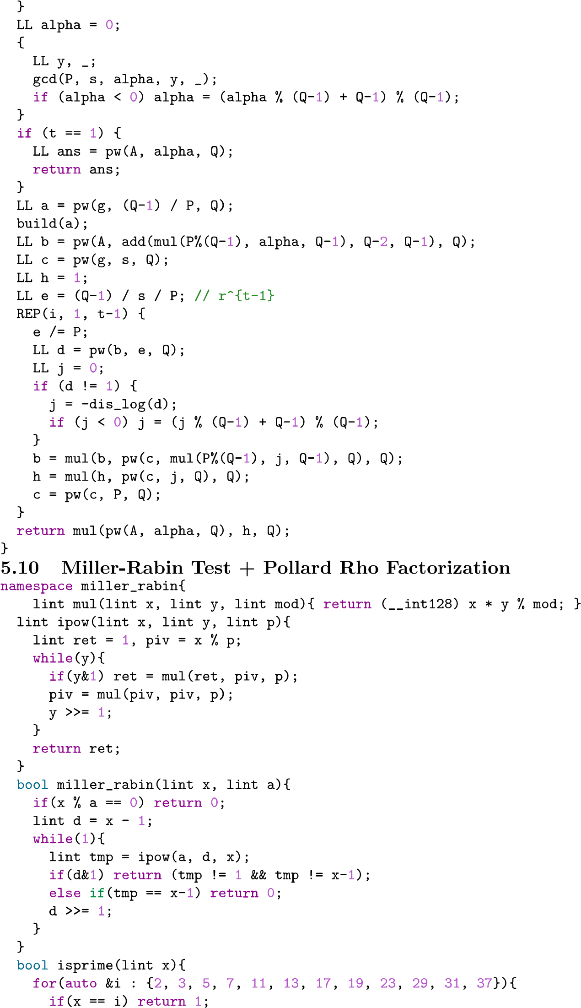

|  |  |
| --- | --- |
| #pragma GCC optimize("O3")  #pragma GCC optimize("Ofast")  #pragma GCC optimize ("unroll-loops")  #define _USE_MATH_DEFINES  #include <bits/stdc++.h>  #define fastio ios::sync_with_stdio(false); cin.tie(nullptr)  #define X first  #define Y second  #define pb push_back  #define sz(x) (int)x.size()  #define all(x) x.begin(), x.end()  #define pii pair<int, int>  #define pll pair<ll, ll>  #define mid ((l+r)>>1)  #define INPUT_FILE "input.txt"  #define OUTPUT_FILE "output.txt"  //ifstream input(INPUT_FILE);  //ofstream output(OUTPUT_FILE);  using namespace std;  typedef long long ll;  const int dx[]={ -1, 0, 1, 0, -1, 1, 1, -1 };  const int dy[]={ 0, 1, 0, -1, 1, 1, -1, -1 };  int main() {  fastio;  } | std::string ltrim(std::string s){s.erase(s.begin(),find_if(s.begin(),s.end(),[](int ch){return !isspace(ch);}));return s;}  std::string rtrim(std::string s){s.erase(find_if(s.rbegin(),s.rend(),[](int ch){return !isspace(ch);}).base(),s.end());return s;}  std::string trim(std::string s){s=rtrim(s);s=ltrim(s);return s;}  std::string tolowwercase(std::string s){transform(s.begin(),s.end(),s.begin(),[](unsigned char c){return tolower(c);});return s;}  std::string touppercase(std::string s){transform(s.begin(),s.end(),s.begin(),[](unsigned char c){return toupper(c);});return s;}  std::string removechar(std::string s,std::string r){for(auto i:r){s.erase(remove(s.begin(),s.end(),i),s.end());}return s;}  std::string replace(std::string s,std::string r,char k){for(auto& i:s){for(auto j:r){i=i==j?k:i;}}return s;}  std::vector<std::string> split(std::string s,char k){std::vector<std::string> rec;std::string ts="";for(auto i:s){if(i==k){if((int)ts.size()){rec.push_back(ts);}ts="";}else{ts+=i;}}if((int)ts.size()){rec.push_back(ts);}return rec;}  std::vector<std::string> split(std::string s,std::string k){std::vector<std::string> rec;std::string ts="";for(auto i:s){bool flag=false;for(auto j:k){if(j==i){flag=true;break;}}if(flag){if((int)ts.size()){rec.push_back(ts);}ts="";}else{ts+=i;}}if((int)ts.size()){rec.push_back(ts);}return rec;} |

ll seg[4100000];

ll lzy[4100000];

ll arr[1100000];

ll init(int l, int r, int node){

if(l==r) return seg[node]=arr[l];

return seg[node]=init(l, mid, node*2)+init(mid+1, r, node*2+1);

}

void lazy(int l, int r, int node, int i, int j){

if(!lzy[node]) return;

seg[node]+=(r-l+1)*lzy[node];

if(l^r){

lzy[node*2]+=lzy[node];

lzy[node*2+1]+=lzy[node];

}

lzy[node]=0;

}

void update(int l, int r, int node, int i, int j, ll v){

lazy(l, r, node, i, j);

if(j<l||r<i) return;

if(i<=l&&r<=j){

seg[node]+=(r-l+1)*v;

if(l^r) lzy[node*2]+=v, lzy[node*2+1]+=v;

return;

}

update(l, mid, node*2, i, j, v), update(mid+1, r, node*2+1, i, j, v);

seg[node]=seg[node*2]+seg[node*2+1];

}

ll query(int l, int r, int node, int i, int j){

lazy(l, r, node, i, j);

if(j<l||r<i) return 0;

if(i<=l&&r<=j) return seg[node];

return query(l, mid, node*2, i, j)+query(mid+1, r, node*2+1, i, j);

}